PROJECT ON

SPORTS EVENT MANAGEMENT SYSTEM

**0** |Page











**SUBMITTED TO:**

**SUDEEP BAJIMAYA**

**SUBMITTED BY:**

**KAUSHAL BHATTARAI**

**Batch: 23 ‘A’**

**Computing Project ‘L5DC’**

**NCC ID: ‘00176085’**

**Softwarica College of IT & E-commerce**



# Acknowledgement

I am really grateful because I managed to complete my project (Sport Event Management System) within the time given by our lecturer Mr. Sudeep Bajimaya. I also sincerely thank our course lecturer of Computing Project, Mr. Sudeep Bajimaya for the guidance and encouragement in finishing this project. Last but not least, I would like to express my gratitude to all the friends and respondents for the support and willingness to spend some time to fill in the questionnaires.

# Abstract

**Sports Event Management System** (SEMS) is a web based application that manages all kinds of sports event and the registration of the users in that sports event. This is a simple computerized system which makes registration of users or participants in a particular sport event easy and efficient as compared to previous paper based system. It provides various integrated features to the users for searching a particular sport event as per their interest and register themselves. As well as users can give feedbacks, report, or request to admin about their experience and SEMS. So, Sport Event Management System helps user to register in particular sport event as per their interest in an efficient way.

To develop a project i.e. Sports Event Management System SQL Server for database and php OOP for programming language and to understand context in a better way, valid WBS (Work Breakdown Structure) has been used for breaking down phases into sub phrases. In addition, it will also provide a better view of when to complete the task. The works as per WBS framework has been undertaken, monitored and completed. In this way, project has been completed with certain limitation.

Table of Contents

0

Acknowledgement 1

Abstract 2

Chapter-1 Introduction 8

1.1 Introduction to the Project 8

1.2 System Background 8

1.3 Overview of Project 8

1.4 Justification of Project 9

1.5 Aims and objectives 9

Chapter 2 Analysis 11

2.1 Analysis Methodology 11

Analysis Methodology Steps 12

DFD 13

2.2 Information Gathering 15

2.3 Feasibility Study 17

2.4 SRS (Software Requirements and Specifications) 18

2.4.1 Functional Requirements 18

2.4.2 Non-Functional Requirements 19

2.4.3 MOSCOW prioritization 20

2.4.4 Hardware/Software Spec 22

2.5 Use Case Diagram 23

2.6 System Architecture 25

3-tier Architecture 25

2.6.1 NLA (Natural Language Analysis) 26

2.6.2 Initial Class Diagram 27

Chapter - 3 Design 28

3.1 Structural Modelling 28

3.1.1 Final Class Diagram 28

3.2 Flowchart 30

3.3 Behavioral Modelling 33

3.3.1 Activity Diagram 33

3.3.2 Sequence Diagram 38

3.4 Data Modelling 43

3.4.1 Data dictionary 43

3.4.2 ER diagram 45

3.5 UI Modelling 46

3.5.1 Prototyping 46

Chapter-4 Implementation 51

4.1 Introduction 51

4.1.2 Technology Stacks 51

Chapter-5 Testing 52

5.1 Black-box Testing 53

5.2 Unit-testing 70

Chapter-6 other project issues 76

6.1 Limitations 76

6.2 Future Work 76

6.3 Risk Management 76

6.4 Configuration Management 77

6.5 Other project issues 77

6.6 User Manual 78

Chapter-7 Conclusion 80

Appendix 81

Table of Figures

Figure 1: DFD for user 12

Figure 2: DFD for Admin 13

Figure 3: Use case diagram for admin 22

Figure 4: Use Case diagram for User 23

Figure 5: 3-tier architecture 24

Figure 6: Initial class diagram 26

Figure 7: Final Class Diagram 28

Figure 8: Admin’s work Flowchart 30

Figure 9: User's work flowchart 31

Figure 10: Login Activity diagram 34

Figure 11: User Activity diagram 35

Figure 12: Admin Activity diagram 36

Figure 13: Login Sequence diagram 39

Figure 14: User Sequence diagram 40

Figure 15: Admin Sequence diagram 41

Figure 16: Data dictionary of User table 42

Figure 17: Data dictionary of Event table 42

Figure 18: Data dictionary of Event Registration Table 43

Figure 19: Data dictionary of User type table 43

Figure 20: Data dictionary of Event type table 43

Figure 21: ER diagram 44

Figure 22: Login Page 45

Figure 23: Registration Page 46

Figure 24: Home Page 47

Figure 25: Prototype of Events Page 47

Figure 26: Gallery Page 48

Figure 27: Admin Dashboard 48

Figure 28: Prototype of Contact Us page 49

Figure 29: Notifying invalid login 52

Figure 30: Logging as admin 53

Figure 31: Admin dashboard after logging as admin 53

Figure 32: logging as user 54

Figure 33: Home page after successful login as user 54

Figure 34: Notifying password and confirm password does not match 55

Figure 35: Login page after successful registration 56

Figure 36: Error notification notifying to fill the required fields 57

Figure 37: New event has been added successfully 58

Figure 38: Updating event details 59

Figure 39: Badminton event's image has been updated successfully 60

Figure 40: Boxing event has been deleted successfully 61

Figure 41: Notifying to fill the required event name 62

Figure 42: searching a particular event with event name 63

Figure 43: Result after searching with event name 63

Figure 44: Notifying to login first for registration in event 64

Figure 45: successfully registered in event after logging in 65

Figure 46: Notifying to login first for cancelling the registration in event 66

Figure 47: Registration in event cancelled successfully 67

Figure 48: Page before logging out 68

Figure 49: Home page after logging out 68

Figure 50: invalid testing of adding event 69

Figure 51: successful testing of adding event 69

Figure 52: testing of empty method 70

Figure 53: Warning 0 assertions 70

Figure 54: testing of setting and getting name 71

Figure 55: test successful 71

Figure 56: testing of setting and getting user id 72

Figure 57: testing id fail 72

Figure 58: testing of setting and getting email 73

Figure 59: testing of email fail 73

Figure 60: testing of setting and getting event name 74

Figure 61: testing of event name fail 74

Figure 62: Events page where one can register themselves in a sport event 77

Figure 63: Click on register to register yourself 77

Figure 64: Page where one can login or register their account 78

Figure 65: contact us page where one can give feedbacks, report or request 78

Figure 66: User class 80

Figure 67: login controller 81

Figure 68: registration controller 82

Figure 69: register in event class 83

Figure 70: register in event controller 83

Figure 71: event class 84

Figure 72: event controller 85

Figure 73: authentication 86

Figure 74: calling of classes 87

Figure 75: to view events 87

Table of tables

Table 1: Notations used in class diagram 28

Table 2: Notations used in flowchart 30

Table 3: NOTATIONS USED IN ACTIVITY DIAGRAM 33

Table 4: NOTATIONS USED IN SEQUENCE DIAGRAM 38

Table 5: Risk comparison table 76

# Chapter-1 Introduction

## Introduction to the Project

Sports Event Management System (SEMS) which provides different kinds of management solutions to individuals or group of people. In the current state, almost everybody gets involved directly or indirectly into the sports. So, this system will be able to manage all the sports event related activities and participants in that sport events as required.

## 1.2 System Background

In the past, all the sports event used to be managed through the paperwork/manually that compromises the availability and security of the data. As well as more time was consumed while undertaking various operations.

Therefore, to overcome all the weakness of the manual work or paper based work, a computerized sports event management system is to be used which simultaneously improves overall functionality of the system.

## 1.3 Overview of Project

Sports Event Management System is to be incorporated with the various features to make it more efficient and easily accessible for the users. The system allows admins to control or manage the users/participants as well as all the activities such as editing and viewing events, creating events, managing participants/users etc. Similarly, it also allows users to view all the available sports event and to register themselves for the particular sport event. And admin bears the responsibility for cancelling the user’s registration in that particular event.

## 1.4 Justification of Project

The Sports Event Management System (SEMS) aim is to process a system that manages the activity of many sports at a time. It will also manage the selection activity of individuals or group of people to college to state level in an efficient way. As it is computerized, it will consume less amount of time as compared to manual paperwork while performing various operations. Data storing will also be easier and safe in comparison.

## 1.5 Aims and objectives

Aims of this project are;

* To deal with the selection of individual or group of people regarding sport events.
* To perform required activities in an easy and quick manner with efficient interface.

Main objectives are;

* To set up or process a well-managed and effective sport event management system.
* To provide a platform for managing all type of sport activities.
* To provide a platform for users to get information and to maintain their active participation in sports event.
* To learn (Object Oriented Programming) OOP php and develop the system.
* To keep the system secure and functional.

# Chapter 2 Analysis

Analysis means evaluation of examination of any data. In other words, Analysis is a process of dividing a complex topic into smaller parts so that every detail of that topic can be covered. It is done specially to gain every knowledge associated by determining its nature or essential features.

## 2.1 Analysis Methodology

Hard Approach methodology is used for the analysis of this project (Sports Event Management System). Hard approach methodology is the way that focuses on the sequential or highly structured approach to analysis. It is mainly used for large and complex projects and also can be used for small projects where technical aspects need to be considered more than the human aspects. So, in this project as well technical or logical aspects are to be focused more than the human aspects.

Therefore, according to the nature and requirements of the project, **SSADM** (**Structured System Analysis and Design Methodology**) is used.

Mainly SSADM focuses on the three Views of a system. They are;

**Process View**

It describes the process that is carried out in the system i.e. how data moves and are processed into the system.

**Data View**

It describes all the data that is used by the system.

**Event View**

It describes the events that runs the system processes and the effects caused by the external events on data.

The project is based on water fall methodology. And SSADM is similar to the Water fall Model. Water fall methodology is suitable for that type of projects in which the requirements are pre-defined and second step is started only after the completion of first step.

Likewise in Waterfall Model there are various steps in SSADM as well. They are;

### Analysis Methodology Steps

**Analysis and Requirement Specifications**

During this step all the aspects such as hardware and software are analyzed and as per the analysis the requirements are defined I.e. technical specifications are produced.

**Design**

As per the analysis done and requirements gathered in the previous step all the aspects of the system are designed i.e. a software is coded, interface as well as database is designed in this step.

**Implementation**

In this step a designed software is implemented as a set of programs or as a unit. Unit testing is also done under this phase to examine if each of the units meet its requirements/specifications or not.

**Testing**

During this phase a system is tested through different testing methods in order to find errors if any. All the program units are integrated and is tested as a whole system to verify whether the system’s requirements are met. After the successive testing, the software is delivered.

**Maintenance**

After the deployment of the software there might arise different errors or problems which was not discovered during the development time of the software. And maintenance is process of fixing such type of errors to improve or enhance the performance of the system. So, this is the phase in which the software is maintained i.e. upgrades and updates are done if required. And all the bugs are fixed.

### DFD

DFD (Data Flow Diagram) is a technique used in this methodology i.e. SSADM that gives an overview or represents the flow of data in the system.

Followings are the DFD for admin and user separately.

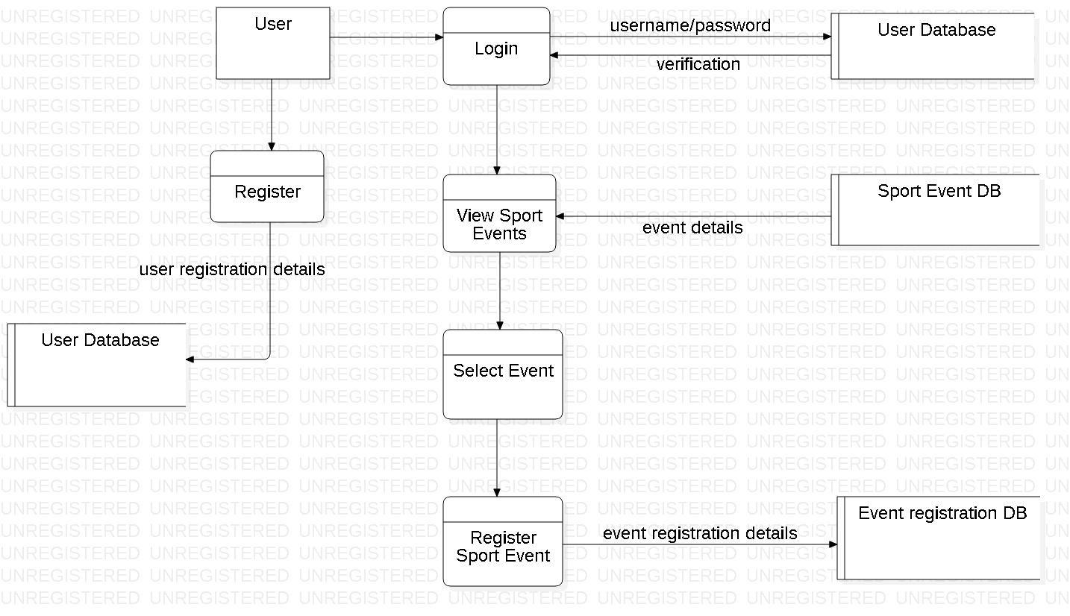

Figure 1: DFD for user

This is a Data flow diagram indicating how data flows in the system while user is using it. It does not provide detail functions but gives an overview of how the data are flowing in the system while user is accessing it.

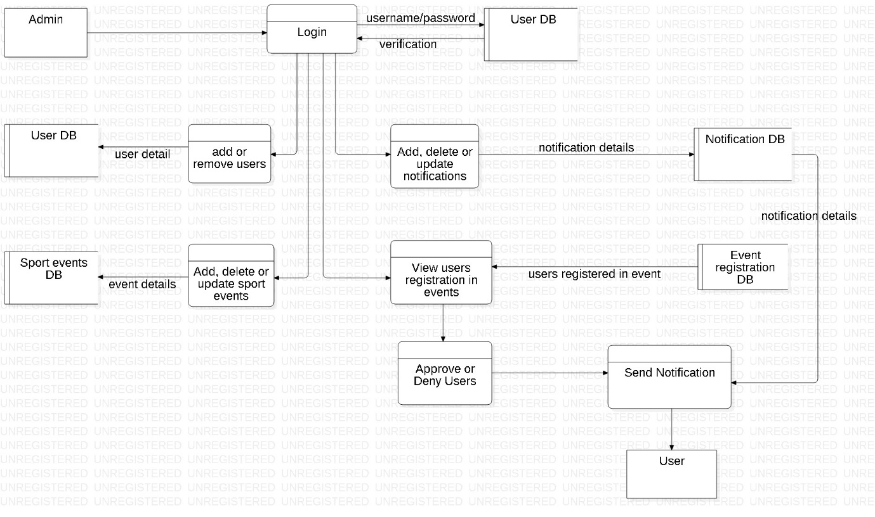

Figure 2: DFD for Admin

This is a Data flow diagram indicating how the data flows in the system while admin is accessing it. This diagram provides an overview of how different functions are flowing in the system and what are the functions or data that are accessed by the admin.

## 2.2 Information Gathering

Information gathering is a process of gathering or collecting different data or information against the targeted system. It is considered as one of the effective way to collect the required information. There are several techniques of gathering information such as Questionnaires, Observations, Focused groups, Interviews, Surveys etc.

And from these techniques I have choose to conduct interview for gathering the required information for the further development of system (Sport Event Management System).

**Interview**

It is an information gathering technique in which various predefined questions based on specific agenda is asked to the targeted victim and the answer is noted. And on the basis of that answer various requirements of the system are analyzed and prioritized. Some of the advantage of taking interview are;

**Advantages**

* High response rate
* More detail questions can be asked.
* More detail information can be gathered.

**Plan for the interview with 10 Persons of Sport Events Management field.**

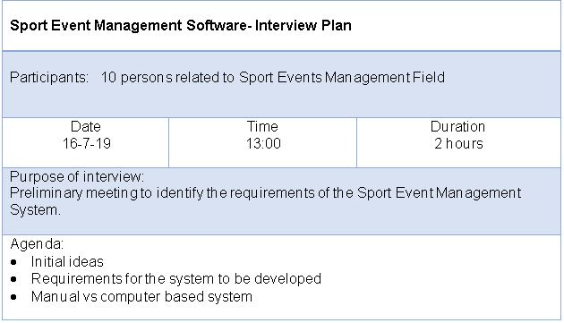

Various subjects based on those agendas were discussed with the number of peoples in belief of gaining positive outcome.

After analyzing the outcome (i.e. answers given by the interviewees) of the interview, it is found that 80 percent of the interviewees have recommended similar type of requirements. However, 20 percent of them have suggested different variety of requirements. So, as more percentage of interviewees recommended similar type of requirements or features such as login, registration, crud functions, searching, filtering etc., I have categorized them as an important features that are to be implemented in the system.

Therefore, conducting interview has assisted a lot in the process of gathering information related to the Sports event Management System.

## 2.3 Feasibility Study

To determine how conveniently or easily something can be done, feasibility study is undertaken. Feasibility study helps to analyze the different factors such as cost, time, social, legal, technical etc. and how will these factors are impacted or maintained during or after the project development. There are various type of feasibility study that can be performed. Some of them are as follows; [Feasibility]

**Economic Feasibility**

The project is not such a large project so, a small amount of budget is sufficient for it. With the allocated budget my project will be completed on time, without lacking in financial resource. In order to determine the economic feasibility more precisely cost/benefit analysis is undertaken. Under this how much cost is allocated for the project i.e. Sports Event Management System and what will be its benefits and vice versa are estimated.

**Technical Feasibility**

Different technological resources are essential for different projects. For this project i.e. Sports Event Management System various technical resources such as Laptop with minimum Core i5 specification, text editor such as brackets, sublime etc. are required. So, all the technical resources to undertake the project are available.

**Time Feasibility**

This (**Sports Event Management System**) project is not so large. Therefore, it will not take long time to be completed. Within the allocated or estimated time, the project will be concluded.

**Social Feasibility**

Underlying on various social constraints the project has been planned. And it will not have any negative impacts on society.

**Legal Feasibility**

The project is planned and will be developed within the legal constraints. It will not violate any rules or regulations. As well as, it is not associated with any of the illegal implications.

## 2.4 SRS (Software Requirements and Specifications)

### 2.4.1 Functional Requirements

The requirements without which a system cannot function or run properly is known as Functional requirements. They defines a functions/components of a system.

|  |  |  |  |  |
| --- | --- | --- | --- | --- |
| **ID** | **Title** | **Description** | **Rational** | **Dependency** |
| **FR01** | Login for Admin | Admin logins to the admin portal of the system | To control/manage the overall process of the system |  |
| **FR02** | Login for User | User logins to the system  through valid username and password | To get access to the validated contents/features of the system | **FR03** |
| **FR03** | Registration for User | Unregistered users register themselves | To be permitted for logging in into the system |  |
| **FR04** | Add sport events | Admin adds the sport events | Added events are viewed by the users |  |
| **FR05** | Update events | Admin updates the sport events if required | Updated events are viewed by the users | **FR04** |
| **FR06** | View events | Users will view the sport events added by admin | To get the detail information of the sport events | **FR02** |
| **FR07** | Send notifications | Notifications of important contents will be sent/received | To increase the availability and accessibility of contents of the system |  |
| **FR08** | Search events | Users can search the events as they want | To locate/select the favorite sport event | **FR02** |
| **FR09** | View registered events | Admin views the registration of users in various events | To manage the users as per registration |  |
| **FR10** | Adding & Removing users | Admin adds or removes the user | To manage the number of users | **FR03,FR01** |
| **FR11** | Approving users | Admin approves the valid users registration request | To make user eligible for participating in particular event |  |
| **FR12** | View score updates | User can view score after the sport event | To know the details of that particular event | **FR02** |
| **FR13** | View schedules | User can view schedules of the events | To know the detail information of the events | **FR02** |
| **FR14** | Registration in events | User can register them into the sport event they want | To take part in the interested sport event | **FR02** |
| **FR15** | Update profile | User can update their profile details | To change the details if required | **FR03,FR02** |
| **FR16** | Cancel registration of events | User can cancel their registration in events | To call of, their previous decision of registering |  |

### 2.4.2 Non-Functional Requirements

The requirements that assures the system’s quality rather than functionality is known as Non-Functional Requirements. They are also known as Quality Attributes of a system. Followings are some of the Non-functional requirements of the (Sport Event Management system) system.

|  |  |  |  |
| --- | --- | --- | --- |
| **ID** | **Title** | **Description** | **Dependency** |
| **NFR01** | Security | To make the system secure different validations and authentications for the user and admin are done. |  |
| **NFR02** | Maintainability | Even after the completion of system if any bugs or errors arise then they are handled by upgrading or updating as required. |  |
| **NFR03** | Performance | Any tasks or process done by the system maintains the response time in order to deliver the better performance. | **NFR09** |
| **NFR04** | Data Integrity | Hashing algorithms are used for passwords to maintain the data integrity. | **NFR01** |
| **NFR05** | User friendly | To make the system more user friendly, unfamiliar or vague contents are not used. |  |
| **NFR06** | Availability | The system can be obtained or used in a quality manner. |  |
| **NFR07** | Serviceability | The system will provide a good service to its users. |  |
| **NFR08** | Reliability | The system will provide a consistent performance which can simultaneously gain the trust of the users. | **NFR04, NFR06** |
| **NFR09** | Scalability | As per the work lengths the system will be able to perform or the system is capable of performing in variable ranges. |  |

### 2.4.3 MOSCOW prioritization

MOSCOW is a method of prioritizing the features or requirements, on the basis of which a system can be developed in a quality way. It helps to prioritize the requirements in more details than the other methods.

Therefore, I have used MOSCOW prioritization method for categorizing the requirements.

**M**O**SC**O**W** stands for

**M-** Must have: The features that should not be neglected or without which a system is incomplete.

**S-** Should have: The features that are of high importance but not that vital.

**C-** Could have: The features that are nice to have but are not essential for the core functionality.

**W-** Won’t have: The features that are not suitable for current timeframe or can be implemented in future for further improvements.

|  |  |  |  |
| --- | --- | --- | --- |
| **ID** | **Title** | **MOSCOW** | **Description** |
| **R1** | Login for Admin | **M** | It is a fundamental feature without which there will be no validation for admin-login and admin will not be able to manage the users and other contents of the system as well. |
| **R2** | Login for User | **M** | It is also a must have feature without which validation of the user cannot be done. |
| **R3** | Registration for User | **M** | Without this feature user cannot get enrolled into the system. So, it is essential. |
| **R4** | Add sport events | **M** | Without sport events system cannot be completed. |
| **R5** | Update events | **M** | While adding events if some details are missed then update should be done as quick as possible in a way that the user should not be aware about it. |
| **R6** | View events | **M** | It is a must have feature because without this user cannot view the events they are interested or may result in incomplete system. |
| **R7** | Send notifications | **C** | It is prioritized as could have because it is good to have but does not play a significant role in core functionality. |
| **R8** | Search events | **S** | It is important feature because if user does not find their desired sport event on viewing whole events, then they can search the specific sport event. So, it is prioritized as should have and not as must have. |
| **R9** | View registered events | **M** | All the registered events should be viewed by the admin to approve the valid one and to deny the invalid ones. So, it is a must have requirement. |
| **R10** | Adding & Removing users | **M** | Users must be added and removed by the admin in order to manage the limited number of users. So, it is also a must have requirement. |
| **R11** | Approving users | **M** | It is also a must have requirement because all the users are to be approved by the admin in order to maintain the validity of users. |
| **R12** | View score updates | **C** | It is a feature which could be implemented in the future. So, it is could have requirement. |
| **R13** | View schedules | **M** | It is also must have requirement because user must be able to view the schedules of the events that are going to be held. |
| **R14** | Registration in events | **M** | User must be able to register them in interested sport event to take part in it without which events cannot be commenced. So, it is a must have requirement. |
| **R15** | Update profile | **M** | If required user must be able to update their profile details in a quick manner. So, it is a must have requirement. |
| **R16** | Cancel registration of events | **S** | User may change their mind to reverse their decision of registering them in the events. So, feature of cancelling the registration should be implemented. |
| **R17** | Security | **S** | Login validations or contents validation maintains the security of the system from unauthorized access. So, it is should have requirement. |
| **R18** | Maintainability | **C** | It is could have requirement because it is done after the deployment of the system and will not impact in the functionality of the system. |
| **R19** | Performance | **S** | A system should maintain the response time of any processes for the better performance. So, it is should have requirement. |
| **R20** | Data Integrity | **S** | If the data of the system is changeable then there will be lack of consistency. So, it is should have requirement. |
| **R21** | User friendly | **S** | This is should have requirement because without user friendly a system cannot be good or efficient. |
| **R22** | Availability | **S** | Without this requirement the system’s data or information could not be used/obtained in a quality manner. So, it is should have requirement. |
| **R23** | Serviceability | **C** | This is also a requirement good to have but is not much important for the main functionality of system. |
| **R24** | Reliability | **S** | A system should be reliable i.e. it should perform consistently and without this requirement a system will not be qualitative. So, it is should have requirement. |
| **R25** | Scalability | **S** | Without this requirement a system will not be capable of performing at different ranges/lengths as per work. So, it is should have requirement. |

### 2.4.4 Hardware/Software Spec

Hardware and software that will be required during the development or before the release of the system i.e. (Sports Event Management System) are as follows;

**Hardware Specification**

* **Processor:** Laptop with minimum core i5 processor
* **RAM:** Minimum 2GB
* **Hard disk:** Minimum 10 GB

**Software Specification**

* **Text editor (Brackets)**

It is used for coding the program.

* **Star UML**

It is used for designing or modelling activity diagram, class diagram, use case diagram, etc.

* **My SQL**

It is used for creating database.

* **Operating system:** Windows 10 (34 or 64 bit)

## 2.5 Use Case Diagram

A use case diagram is a graphic depiction of the interactions among the elements of a system.

Elements used in use case diagrams;

**System Boundary:** It separates an internal system with respect to external actors.

**Actor:** It may be anyone that interacts with the system or in some case system itself.

**Use case:** Different functions of the system that are accessed by the actors are identified as use cases and are associated to the respective actors.

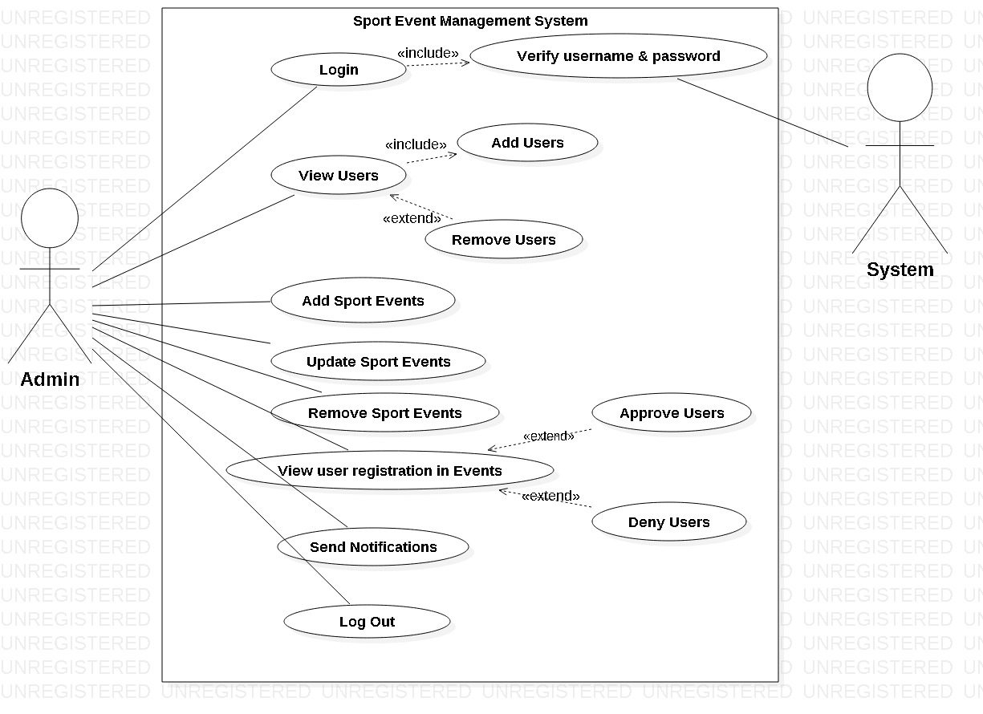

Figure 3: Use case diagram for admin

**Actor 1:** Admin is the first actor in this use case diagram. All the features of the system that are accessed by admin are identified as use cases and associated in the above use case diagram.

**Actor 2:** Second actor in this use case diagram is System itself. All other functions are done by the admin whereas the verification of the admin is done by the system.

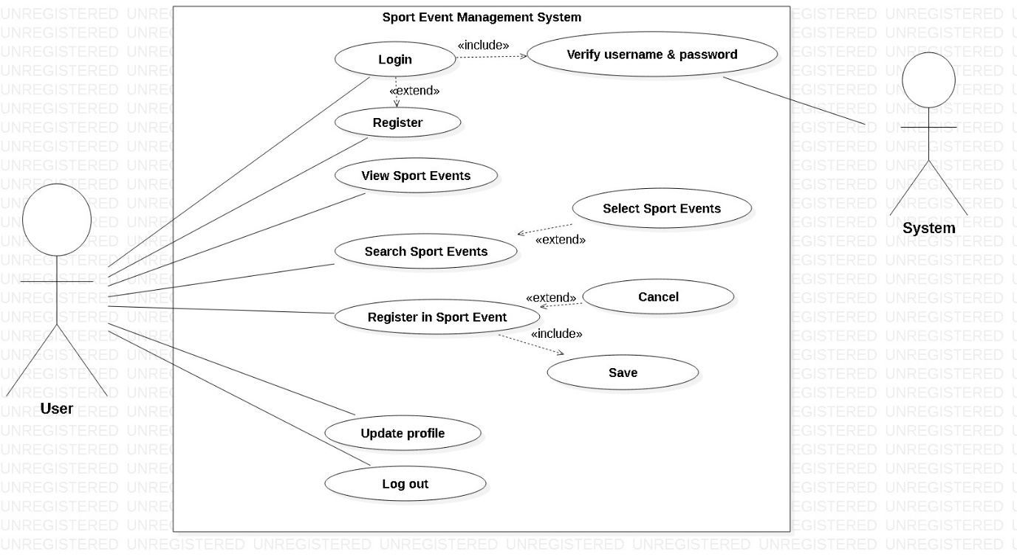

Figure 4: Use Case diagram for User

**Actor 1:** In this use case diagram user is the first actor and all the features or functions of the system that are accessed by them are identified as use cases and are associated.

**Actor 2:** System itself is the second actor in this use case diagram that verifies the user to permit them for accessing other functions of the system.

## 2.6 System Architecture

### 3-tier Architecture

A 3-tier is a client-server architecture that facilitates the use of object oriented concepts and data security through application layer.

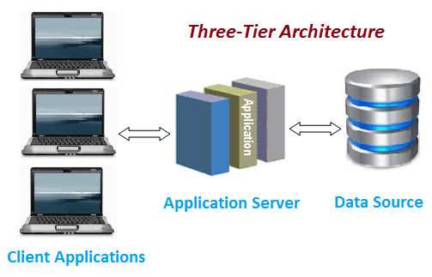

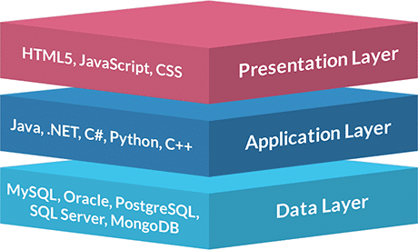

Figure 5: 3-tier architecture

This system i.e. Sport events management system consists of various services and resources which is to be presented to the clients or users via server as requested. And 3-tier architecture is the best to fulfill this requirement of a system as it is a client-server architecture. It also enables the faster migration to new graphical environment and object-oriented concepts. Similarly application layer provides data security and changes made to one layer will not have any impact on other layers.

Therefore, 3-tier architecture is a most suitable architecture to this system.

### 2.6.1 NLA (Natural Language Analysis)

It is a process of analyzing the provided scenario to find out all the nouns and verbs that are present. In which nouns represent class and verbs represent method.

**Scenario**

XYZ is a Sport events managing company. It is not a big and reputed company as they are rookie in this field. They manage different Categories of Sport events such as Basketball, Cricket, Football, etc. They are doing all the functions manually which is not benefiting for the growth of their business. So, to upgrade their business they are seeking for an automated computer based Sport event management system. And the system should be able to do the primary requirements such as admin can add, remove, update sport events and users as well as can send notifications, users can view and register in events only after valid registration and login.

Followings are the steps that are considered while performing NLA.

**Step I: Listing of all the nouns / verbs**

**Nouns:** Sports events, company, company, field, Category, Sport events, business, business, computer, Admin, Sport events, Admin, users, user, and notification

**Verbs:** manage, big, manage, type, add, update, delete, add, delete, send, receive, view, login, and register

**Step II: Repeated nouns / verbs as well as synonyms are removed**

**Nouns:** Sport events, company, field, Category, business, Admin, user, notification

**Verbs:** manage, big, type, add, update, delete, send, receive, view, login, register

**Step III: Nouns / Verbs that does not give specific meaning or out of scope are removed**

**Nouns:** Sport events, Category, Admin, User, Notification

**Verbs:** add, update, delete, send, receive, view, login, and register

**Actual Class:** Sport events, Admin, Category, User, Notification

**Actual Methods:** add, update, delete, send, receive, view, login, and register

### 2.6.2 Initial Class Diagram

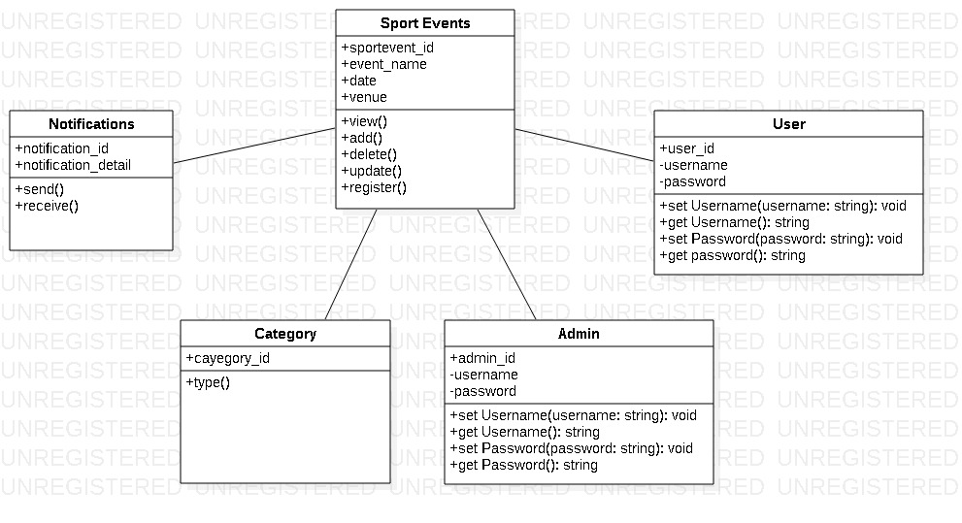

Figure 6: Initial class diagram

Class diagram is the blue print of aspects to build the whole system. It defines how the classes will be working together to develop a system. So, above is the initial class diagram of the Sport events management system that includes main classes along with some attributes and methods. This is only the indication of how the class diagram will look like. But final class diagram will be developed further.

# Chapter - 3 Design

This is the phase where designing or modelling of the system is done as per the gathered requirements. It provides outline of what the system will do and how the processes are carried/performed. This is considered as an important phase during the software development. Structural, Behavioral, Database and UI modelling are various phases of designing.

## 3.1 Structural Modelling

Structural model displays the organization of a system in terms of the relationship between the components. It may be either static or dynamic.

### 3.1.1 Final Class Diagram

Class Diagram is a static structure that defines system by illustrating operations, attributes, objects, classes and their inter-relationship. It works on principles of object orientation and this orientation describes the interaction between objects.

**Justification of using Class diagram**

* The structure of this system i.e. Sports Event Management System can be illustrated by the Class diagram in a detail and appropriate way.
* This project is to be developed using OOP (object oriented programming) and class diagram also works on the principle of OO (Object Orientation).
* By the use of class diagram, relationship between different classes in this system can be easily signified.

**Notations Used**

|  |  |  |
| --- | --- | --- |
| **Name** | **Notations** | **Description** |
| **Public specifier** | + | It is used for those properties which are not to be restricted. |
| **Private specifier** | - | It is used to restrict the privilege of accessing properties between classes. |
| **Association** |  | It is used to represent a relationship between classes. |
| **Multiplicity** |  | It allows statements about the number of objects that are involved in association. |

Table 1: Notations used in class diagram

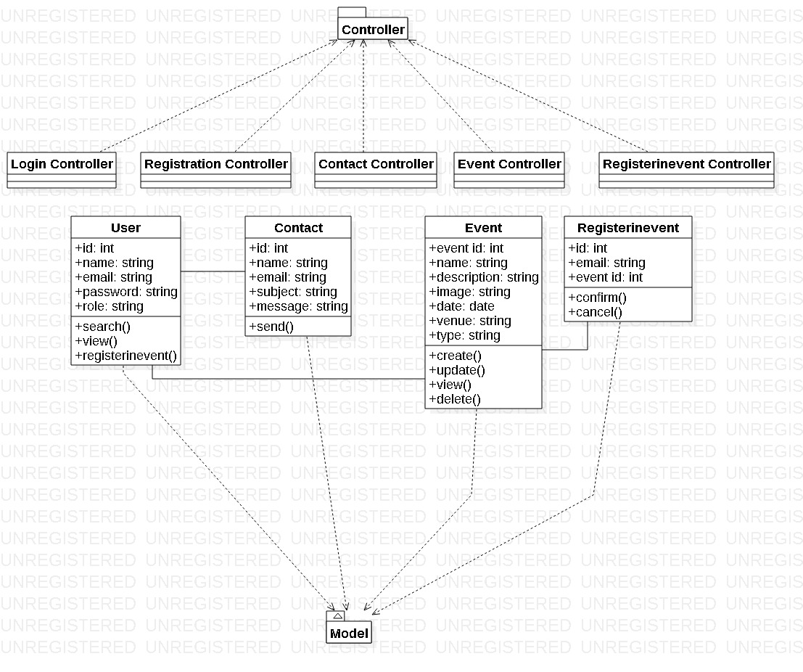

Figure 7: Final Class Diagram

Above is a final class diagram that contains different classes. It follows MVC pattern (i.e. Mode, View, Controller pattern). Every class have its model, view and controller. Different classes are associated with other. Register in event would be incomplete without event sot they are associated with each other. Similarly, event and user are associated with each other.

## 3.2 Flowchart

A flowchart is a graphical representation of the workflow or process in the system .It is also a diagrammatic representation of the step by step task or algorithm. Various boxes or notations are used to describe the processes and are connected with each other to indicate the workflow.

**Justification**

* By the use of flowchart this system’s (i.e. Sport Event Management System) processes can be identified easily.
* Work flow in this system can also be illustrated in a systematic way.
* Multiple progresses and their sequence in this system can be clearly visualized.
* Only the necessary steps are listed in the flowchart which helps to remove unnecessary steps or errors. Simultaneously, it will help to increase the efficiency of the system.

**Notations Used**

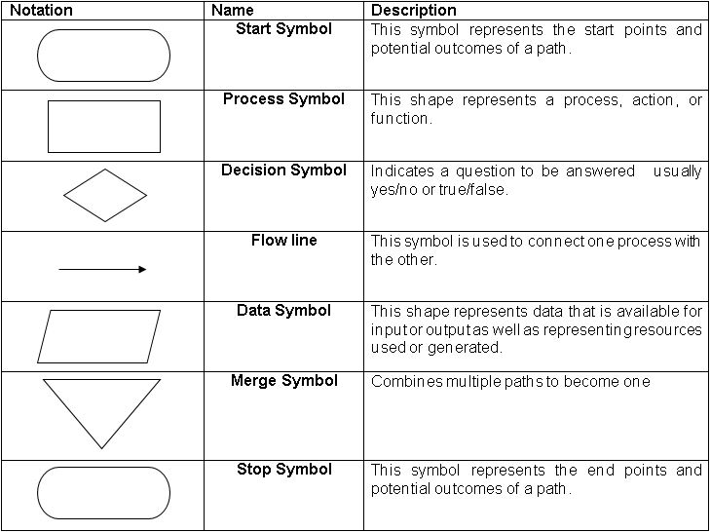

Table 2: Notations used in flowchart

1. **Flowchart showing the workflow of admin in the system**

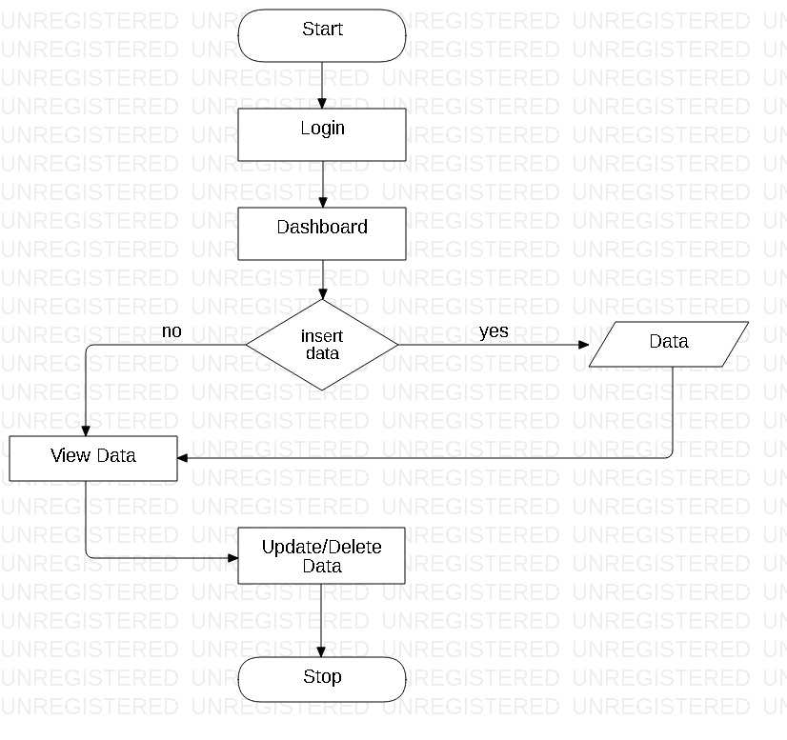

Figure 8: Admin’s work Flowchart

Above diagram shows the flow of the works that are performed by admin in the system. Firstly, admin logs into the system and is re-directed to the admin’s dashboard, where either he/she inserts, updates, or deletes data. If he/she choose to insert data then data is inserted and then it is viewed and if data is not to be inserted then it is viewed in order to update or delete already inserted data as needed.

1. **Flowchart showing the workflow of user in the system**

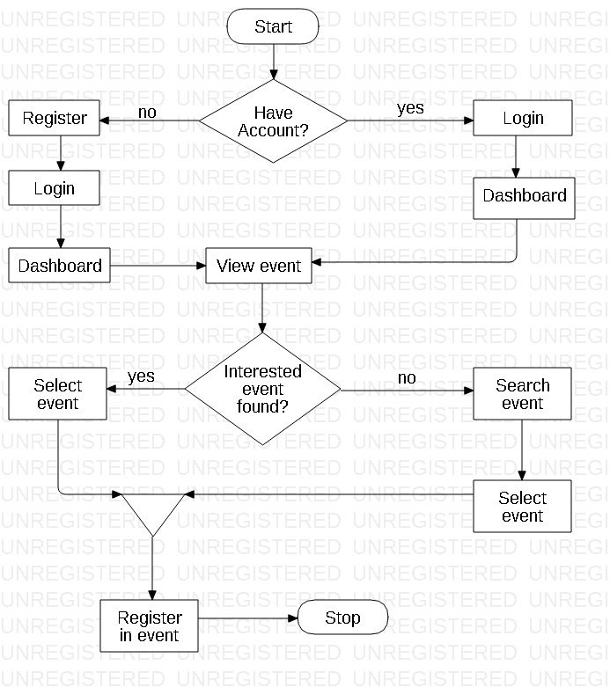

Figure 9: User's work flowchart

Above is the flowchart showing the work flow of the user’s work in the system. Registered users who already have account can login to the system and is redirected to the user’s dashboard and unregistered users should register themselves at first to login. After login they can view events, and can search the particular event they want if they are unable to find one. Then they select that event and register themselves in that particular event.

## 3.3 Behavioral Modelling

Behavioral modelling is a process of creating models that describes the dynamic behavior of the system during the execution phase.

### 3.3.1 Activity Diagram

Activity diagram is a UML behavior diagram that signifies the work flow of stepwise activities of the system. It is also a dynamic structure that represents a flow from one activity to another.

**Justification of using Activity Diagram**

* Activity diagram can be useful for understanding the work flow of this system (i.e. Sport Event Management System).
* Different complicated sequential algorithm in the system can also be described by the use of activity diagram.
* It can also help to analyze the use case of this system.
* Activity diagram can help to illustrate the different activities that is to be done by different actors and sequential flow of those activities in this system.

**Notations used**

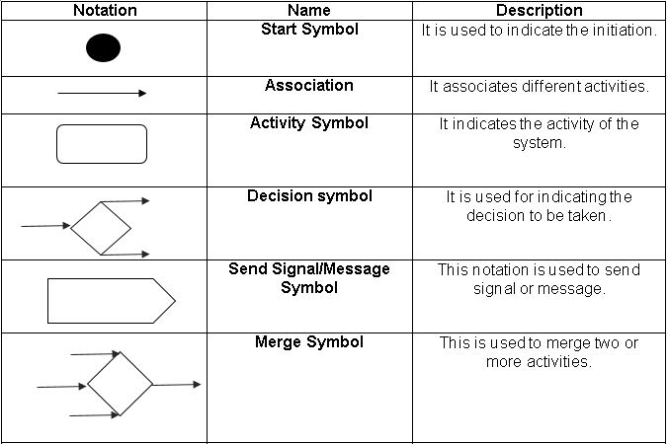

Table 3: NOTATIONS USED IN ACTIVITY DIAGRAM

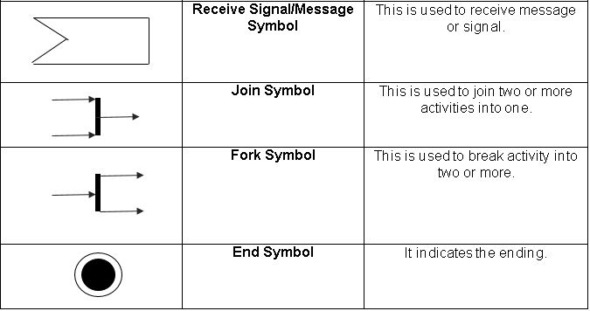

1. Activity diagram illustrating the data flow during the login process in the system.

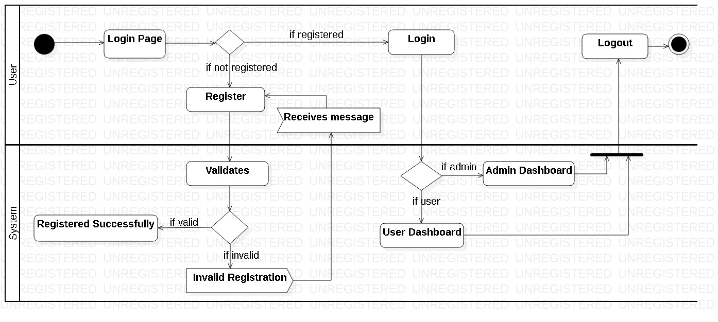

Figure 10: Login Activity diagram

Above diagram shows the activities that are done by the user while logging in to the system. User opens a login page first off all, and if the user is already registered then user directly logs in to the system otherwise user should create a new account or should register themselves. Only after successful registration users can login.

During registration if a user inputs invalid data then system generates error message and the system only generates successful message after the valid registration. Then after the successful registration user logins to the system. And according to the nature of the user (i.e. Admin or normal user) they are directed to the admin or user dashboard respectively where they can use different features of the system. And after the proper involvement with the features the users logs out of the system.

1. Activity diagram illustrating the activities done by the user and the data flow in the system

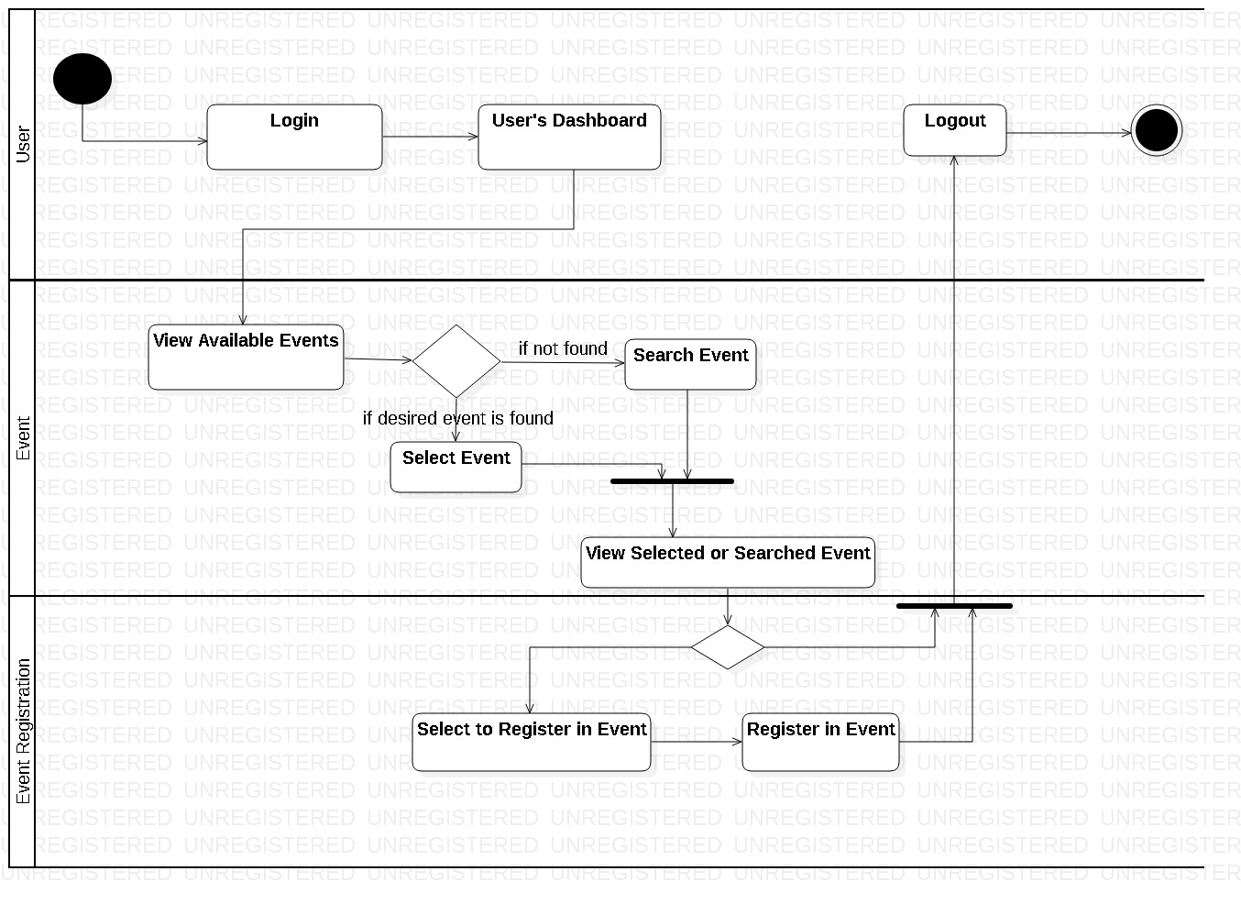

Figure 11: User Activity diagram

This diagram shows the activities done by the user in the system. Users login to the system and are directed towards the dashboard where they can perform various crud functions as well as they can search as they want. Firstly, user views the events that are added by the admin. If they found the event in which they are interested then they can view event details and if they are unable to find the interested event then they can search it.

After finding the interested one, they selects that particular event, views it and selects to registers themselves in that event. Finally, they register themselves in the particular event and logouts of the system.

1. Activity diagram illustrating the activities done by the admin and the data flow in the system

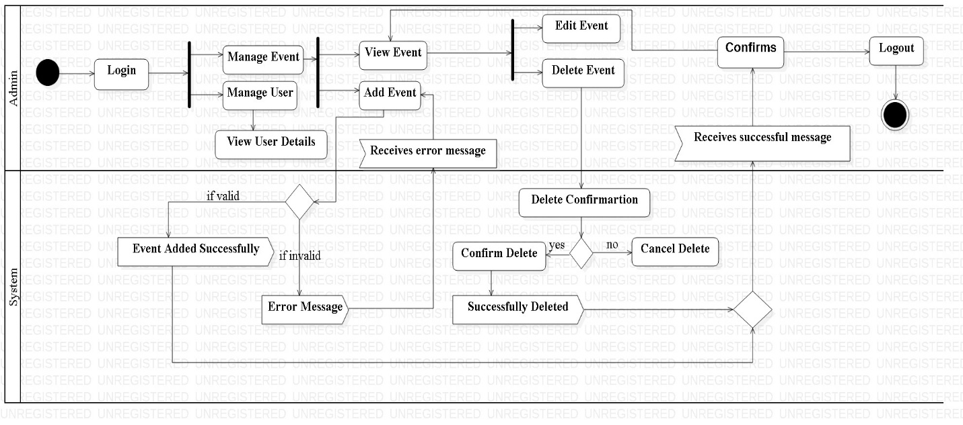

Figure 12: Admin Activity diagram

Above diagram shows the association between the activities done by the admin. Admin logins into the system and is directed to the admin’s dashboard where he/she can manage user s or events. Admin will either manage event first or user second and vice versa. If admin decides to manage users first then he/she views the user details and manage accordingly. And if admin choose to manage events first then he/she will add new events as required, views event that are already added and either deletes them if they are not available anymore or edits the events as needed.

Every time system generates the successful message for valid input and error message for invalid input given by the admin. Then finally after managing the users and the events successfully admin logs out of the system.

### 3.3.2 Sequence Diagram

Sequence diagram describes what in and how a group of objects work together. It is a type of an interaction diagram as it demonstrates the interaction between the objects. [Sequence Diagram]

**Justification of using Sequence Diagram**

* To represent the interaction between the objects in this system sequence diagram can be very helpful.
* This system’s requirement can be easily understand by the use of sequence diagram.
* Behavior of this system over a specific time can also be illustrated by the use of it.

**Notations Used**

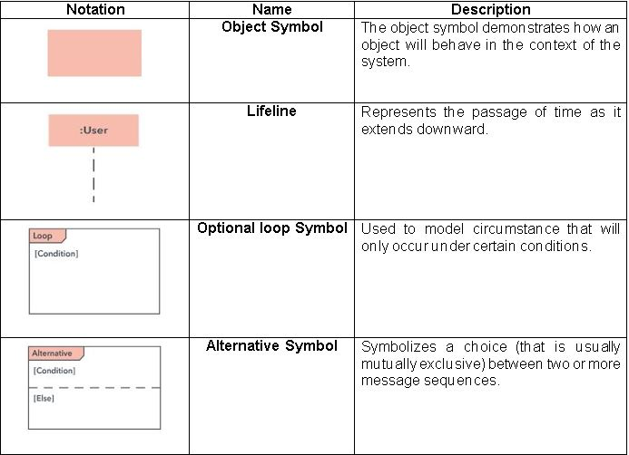

Table 4: NOTATIONS USED IN SEQUENCE DIAGRAM

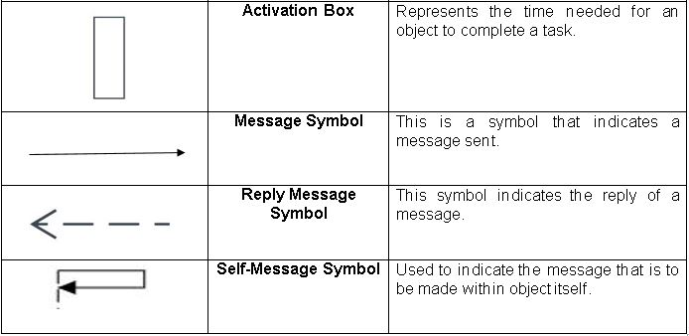

1. Login Sequence Diagram

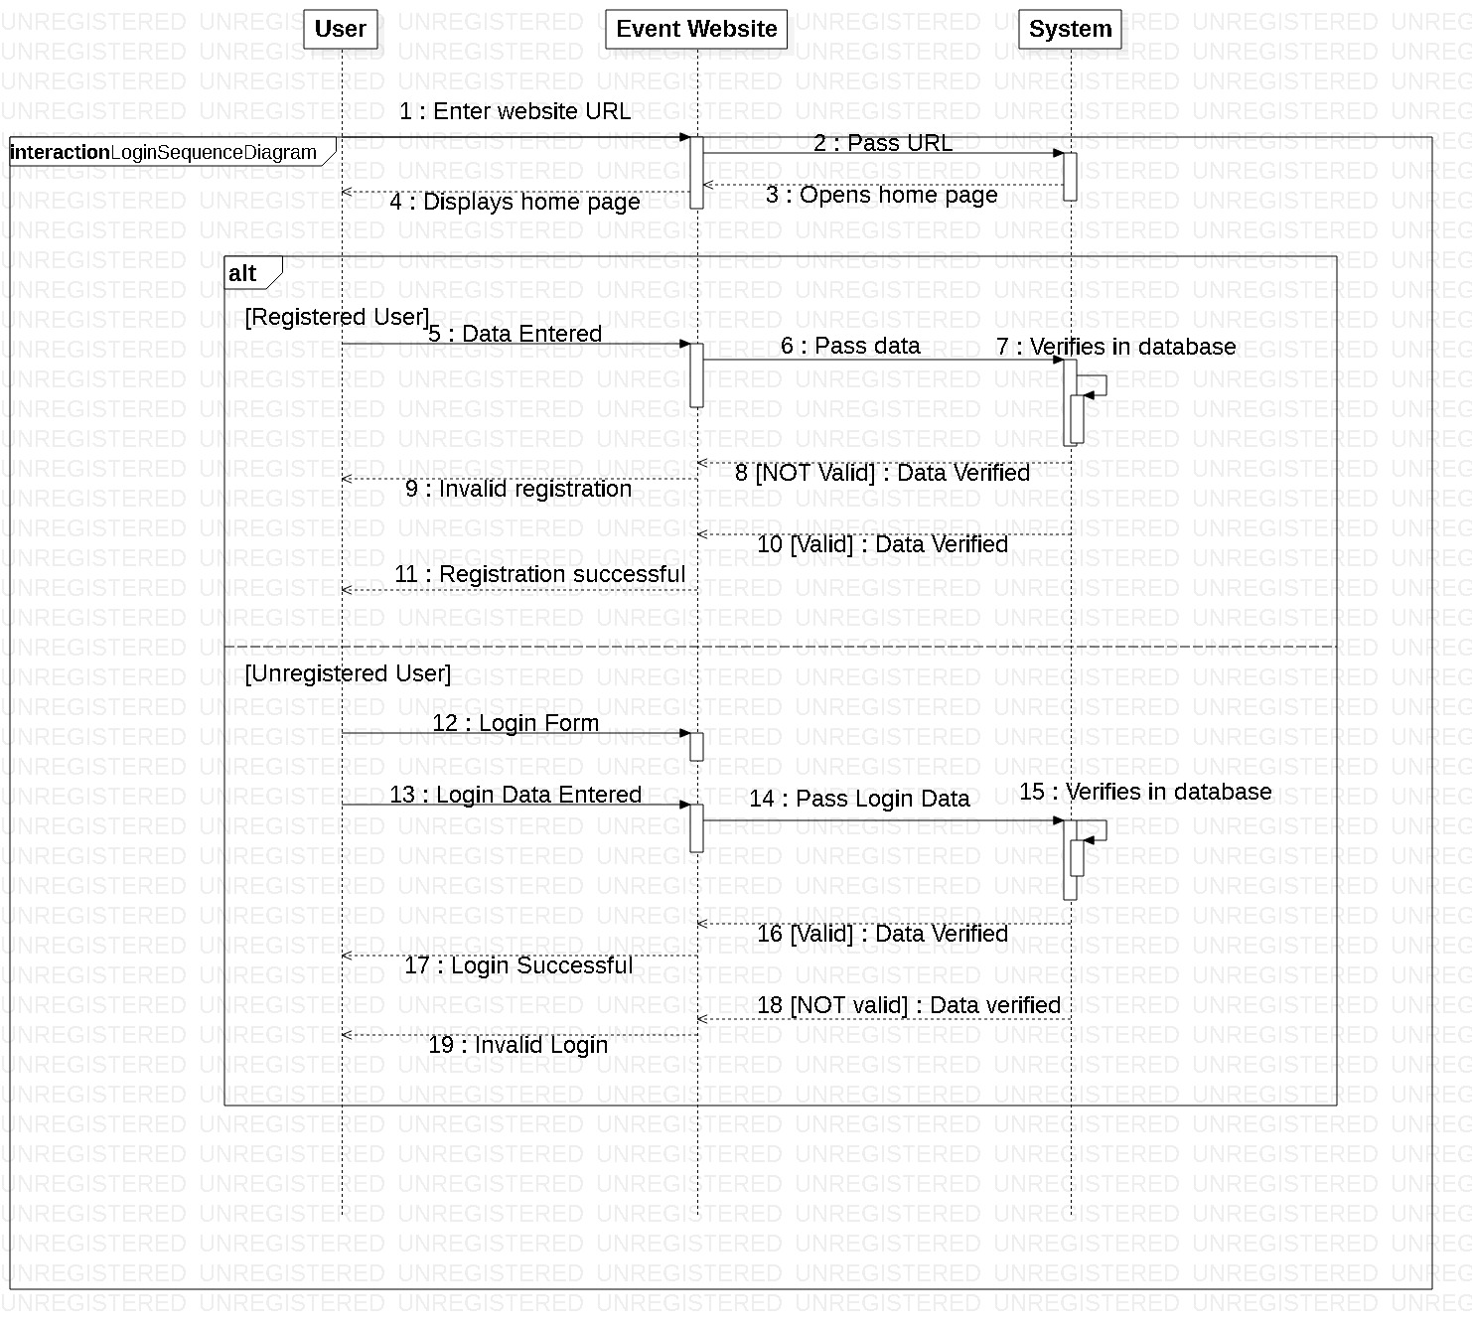

Figure 13: Login Sequence diagram

Above diagram shows the login and registration process done by the registered or unregistered users. Firstly, user enters the website url and gets into the event website and system opens the home page of the website and displays it to the users. Then unregistered user should register themselves to login into the system. Unregistered user enters data in the event website page and that data is passed to the system where it verifies that data and displays result for valid and invalid registration accordingly.

Likewise registered user can directly login in to the system without registration. Registered user opens the login form enters the login data and that data is passed to the system, which verifies them and displays the result as per the verification.

1. User Sequence Diagram

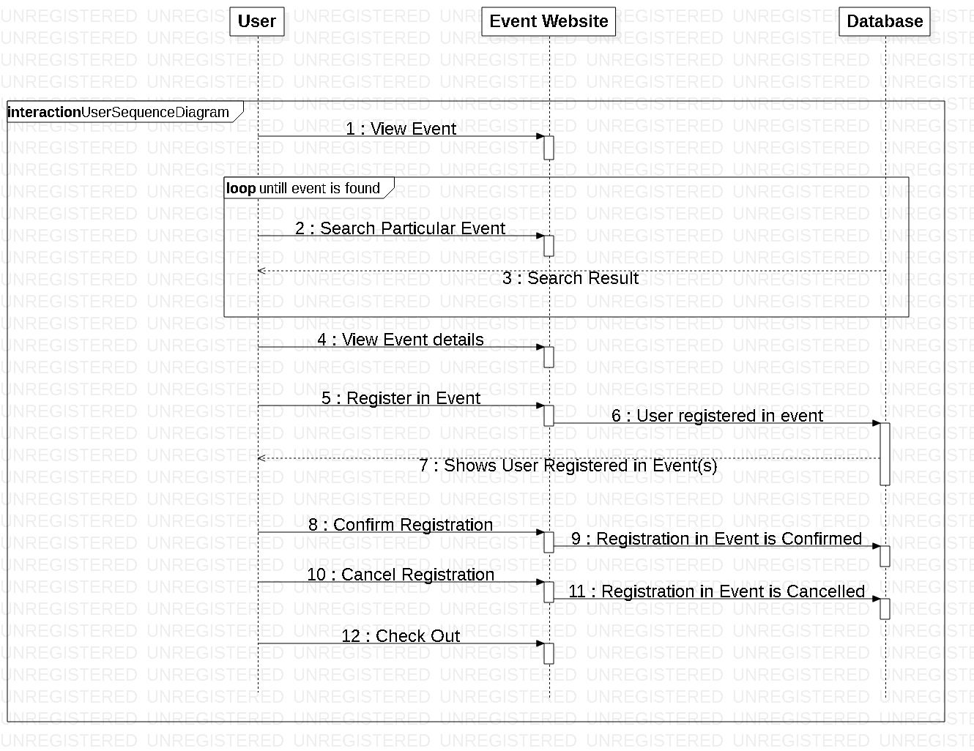

Figure 14: User Sequence diagram

This diagram shows the sequence of the work done by users. Users view the events that are added by the admin, search and views them and chooses whether to register in the event or not. If they choose to register in the particular interested event then they select that event and register themselves in that event. They can confirm their registration or can cancel their registration ass per their interest. And can visit the site for any other event information or exits from the site.

1. Admin Sequence Diagram

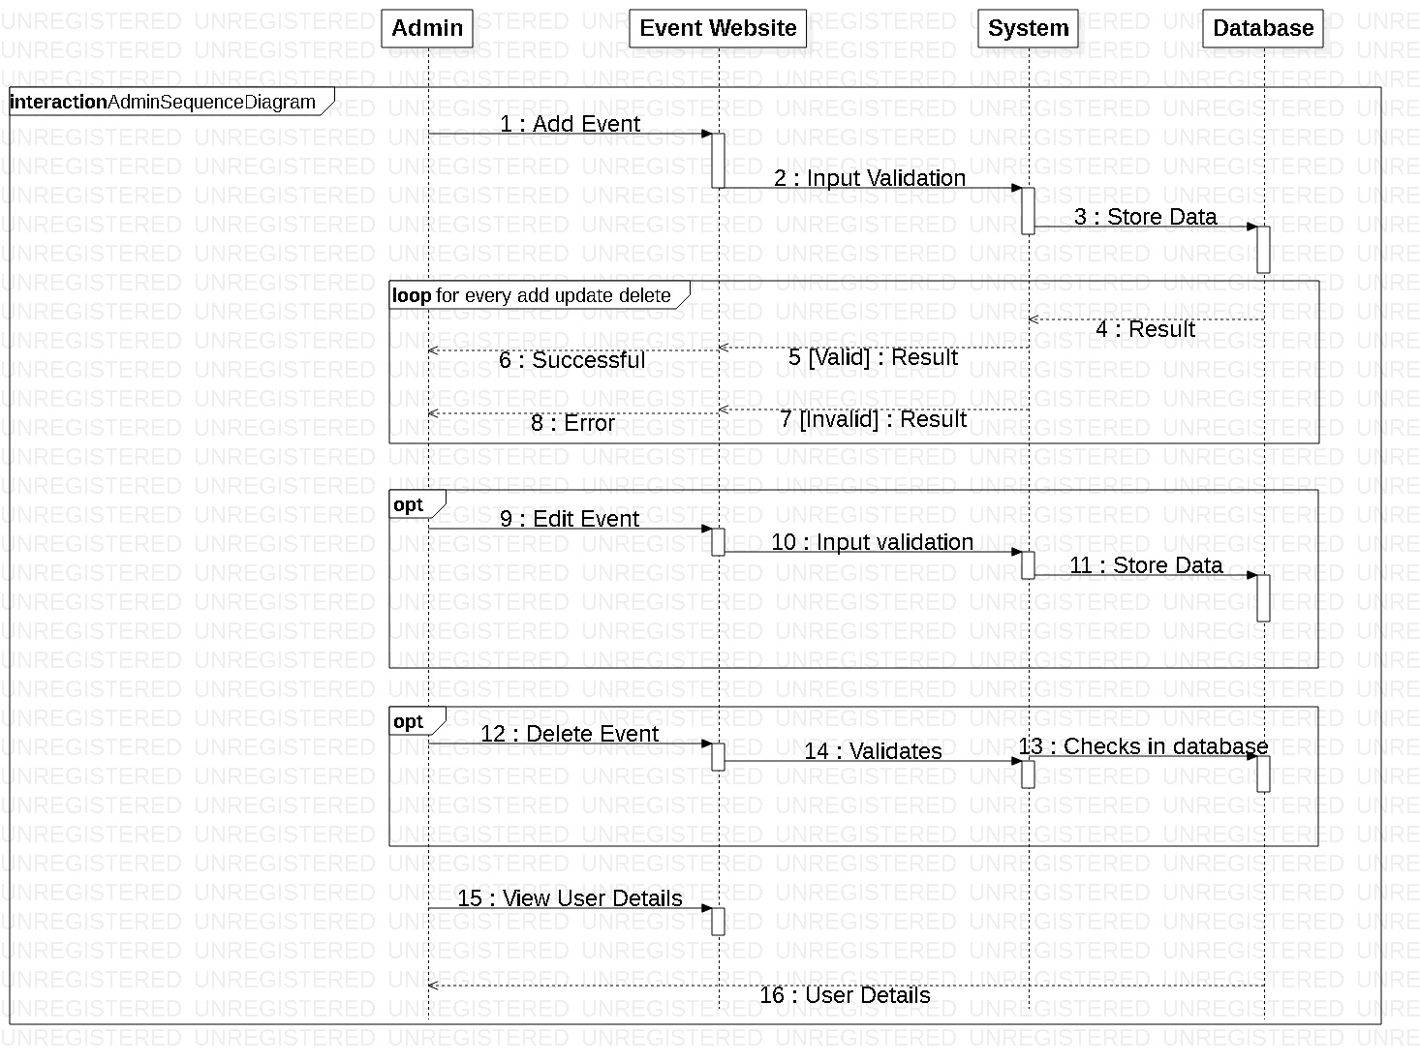

Figure 15: Admin Sequence diagram

Above diagram shows the sequence in which admin’s works are performed. Admin first off all adds event and other event associated details. And edits or deletes them as required. Every time when admin performs adding, deleting or editing functions then system generates error message for invalid input and successful message for valid input. Admin also views the user details in order to manage them.

## 3.4 Data Modelling

It is a process of creating data model for the data that is to be stored in the database. It is also known as the analysis of data objects and their relationship with other data objects.

### 3.4.1 Data dictionary

It is a metadata i.e. data of a data. It is a set of files that contain a database’s metadata. The data dictionary contains various records such as data relationship, data ownership, and other data.

**Justification**

* Data quality of this system (Sport Event Management System) can be improved.
* This system’s data can be analyzed easily.
* Data redundancy in this system can also be reduced.
* Data of this system can also be reused.

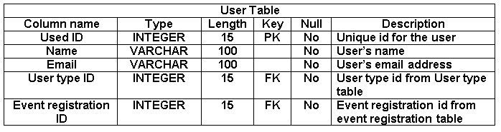

Figure 16: Data dictionary of User table

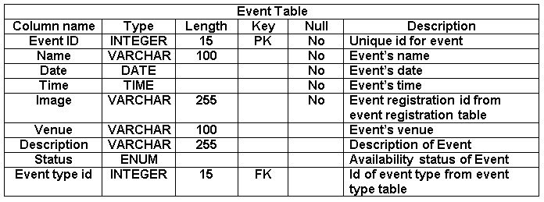

Figure 17: Data dictionary of Event table

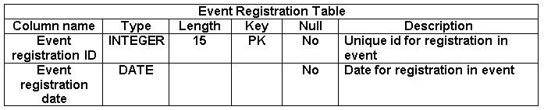

Figure 18: Data dictionary of Event Registration Table

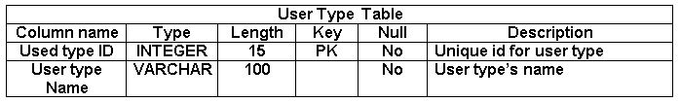

Figure 19: Data dictionary of User type table

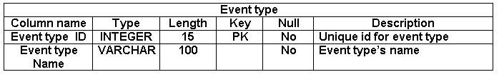

Figure 20: Data dictionary of Event type table

### 3.4.2 ER diagram

ER (Entity Relationship) diagram is a high level conceptual data model. It is a diagrammatic representation of different entities and their relationships.

**Justification**

* It enables better visual representation of this system (Sport Event Management System) i.e. relationship among entities and relationship can be easily understood by seeing ER diagram.
* It is highly flexible so that this systems data can be increased or decreased over a time.
* ER diagram will help to illustrates different entities of this system in a simple and easy way.

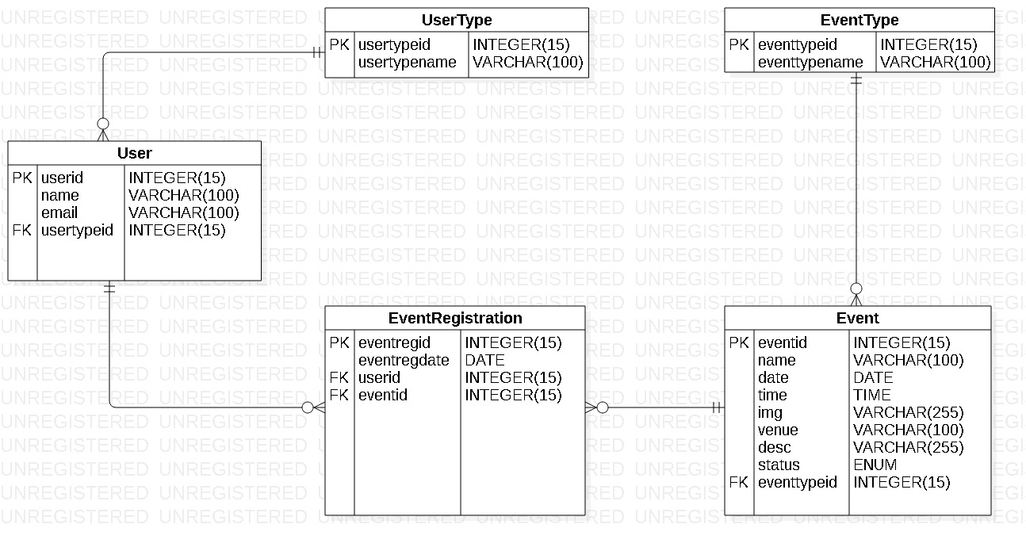

Figure 21: ER diagram

## 3.5 UI Modelling

User Interface modelling is a development technique used to design and develop the interface which will be presented to the users. It plays an important role in achieving better usability.

### 3.5.1 Prototyping

Prototype is a blueprint or sample of the system that is to be developed and released and the process is known as prototyping. Mainly there are two types of prototyping i.e. paper and digital prototyping.

**Justification**

* It can help to reduce the development time of this system i.e. (Sport Event Management System).
* It can act as a reference tool in the process of developing this system.
* In the process of interpreting this systems functionality and requirements, it can help to eliminate ambiguity and improve accuracy.
* It can also help to achieve better usability of this system/software.

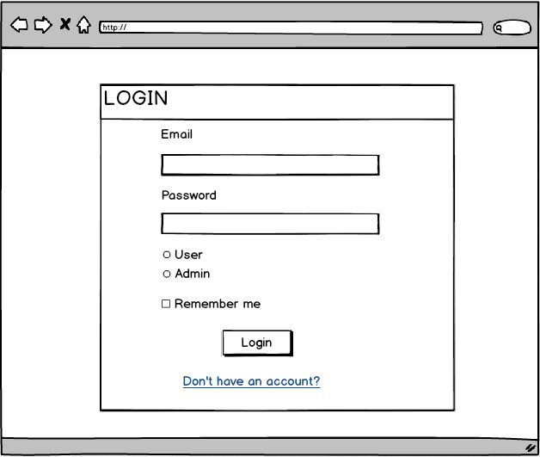

Figure 22: Login Page

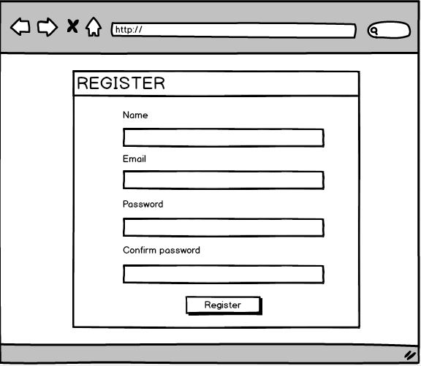

Figure 23: Registration Page

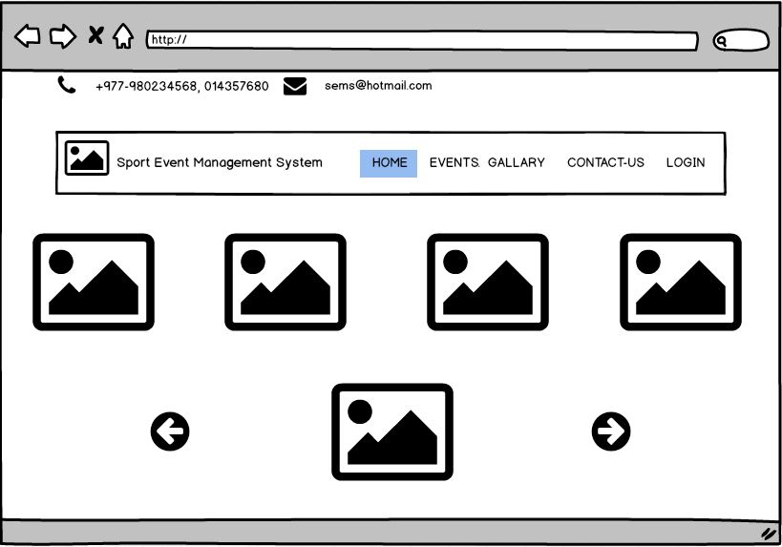

Figure 24: Home Page

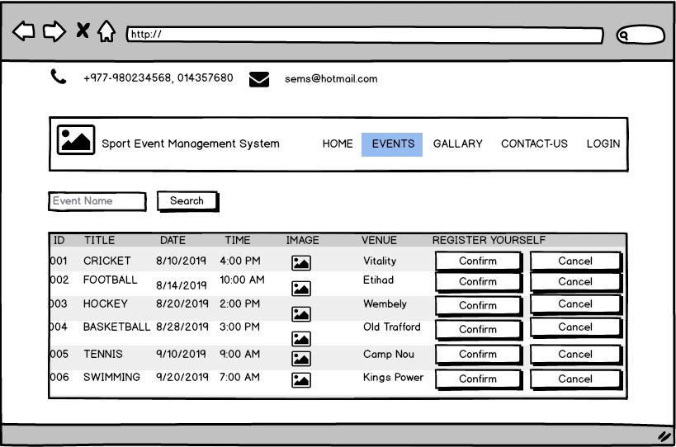

Figure 25: Prototype of Events Page

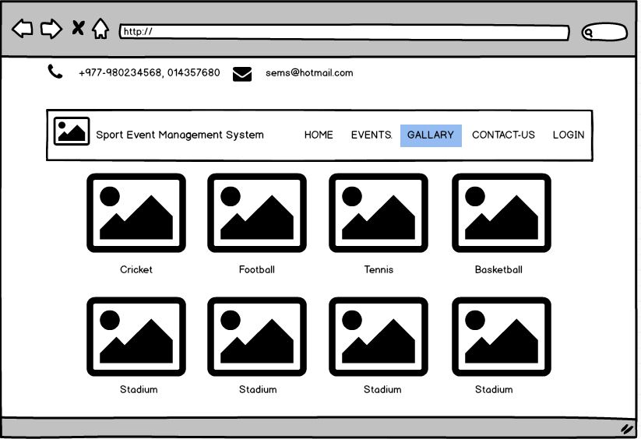

Figure 26: Gallery Page

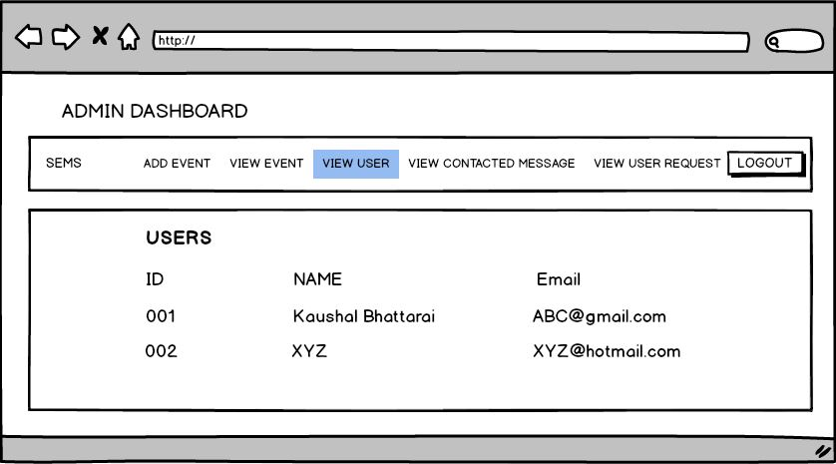

Figure 27: Admin Dashboard

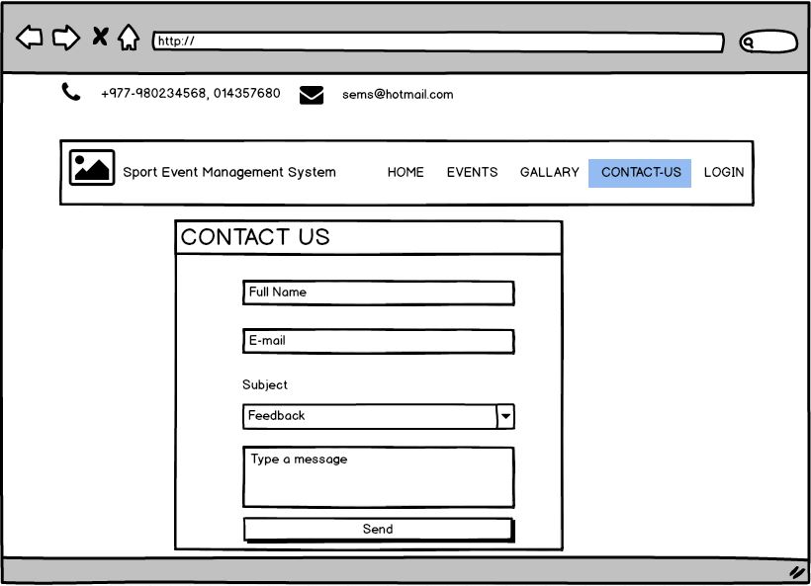

Figure 28: Prototype of Contact Us page

# Chapter-4 Implementation

Coding is an essential part of any project and **all the screenshot of codes done included inside the appendix below.**

### 4.1 Introduction

Sports event Management system is a web-based application that is designed in MVC pattern. This system facilitates the management of users/participators in easy and quick manner.

### 4.1.2 Technology Stacks

#### Language used

Core PHP is used to write this project following the OOP (Object Oriented Programing) concept.

#### Database

MySQL has been used to manage the database and XAMPP is used to create server i.e. Apache server to run the php scripts. Bootstraps, CSS and java-scripts has been used to style the frontend of the project.

# Chapter-5 Testing

**Testing** is the way of examining whether the program or software works as per the requirement or not. It helps to minimize or solve errors and also helps to find out if any.

There are different types of testing such as Black-box testing, Unit testing, Integration testing etc. For testing this system i.e. (Sport Events Management System) especially unit testing and black-box testing are performed.

**Black-box** testing is the way of checking user interface or external design without focusing on the internal functionality or structure of a program.

**Unit testing** is a type of testing that mainly focuses on the functionality and logical workings of the software or program. It is done to examine the program (by dividing it into units) whether it is functioning as required or not.

**Purpose of choosing Unit testing and Black-box testing**

* Black-box testing tests the interface/external design of this system i.e. (Sport Events Management System) which simultaneously makes better interface without complexities.
* Likewise Unit testing examines the functionality of the system by breaking it down into various units to make this system consistent while performing.
* Black-box tests external design/interface whereas Unit testing tests internal functions to check whether they are working as required or not and helps to make this system more precise.

## 5.1 Black-box Testing

Following is a black-box testing of Sport Events Management System.

**Login**

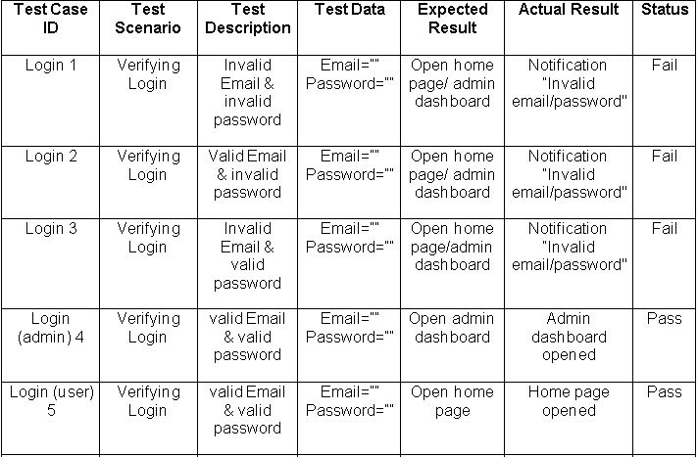

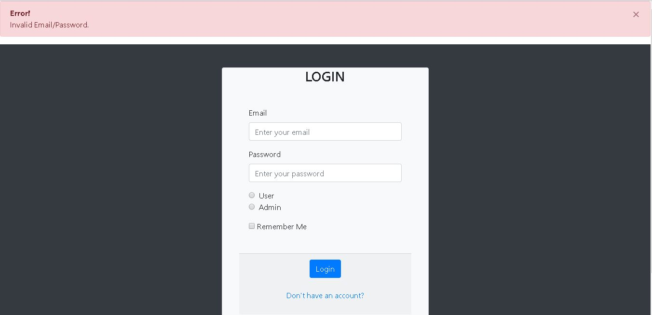

Figure 29: Notifying invalid login

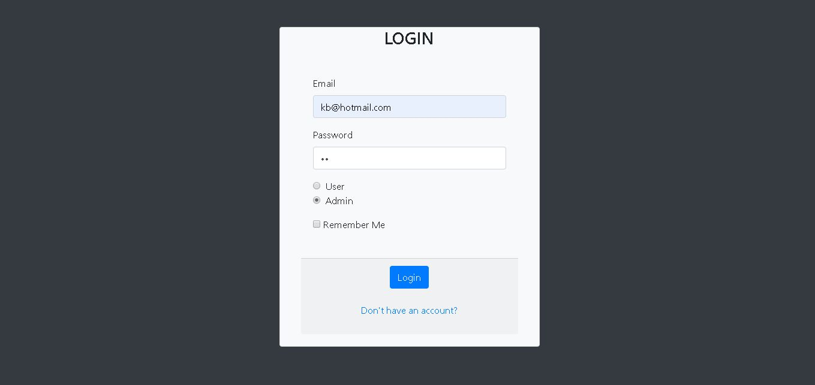

Figure 30: Logging as admin

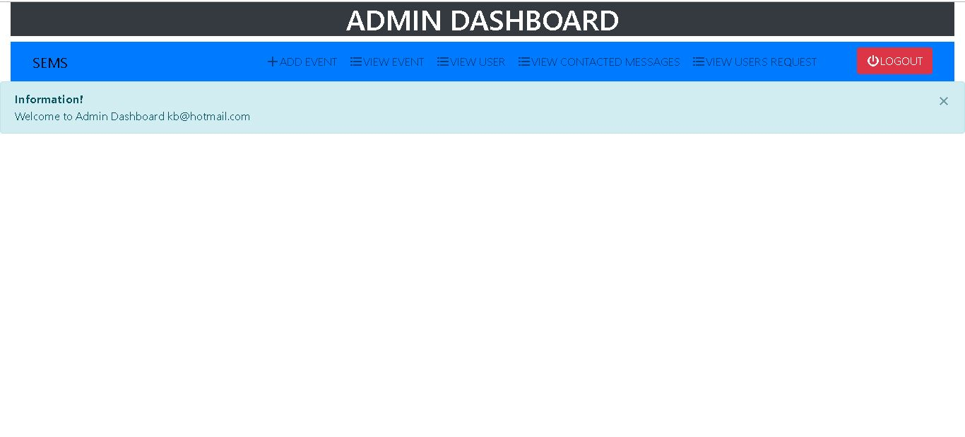

Figure 31: Admin dashboard after logging as admin

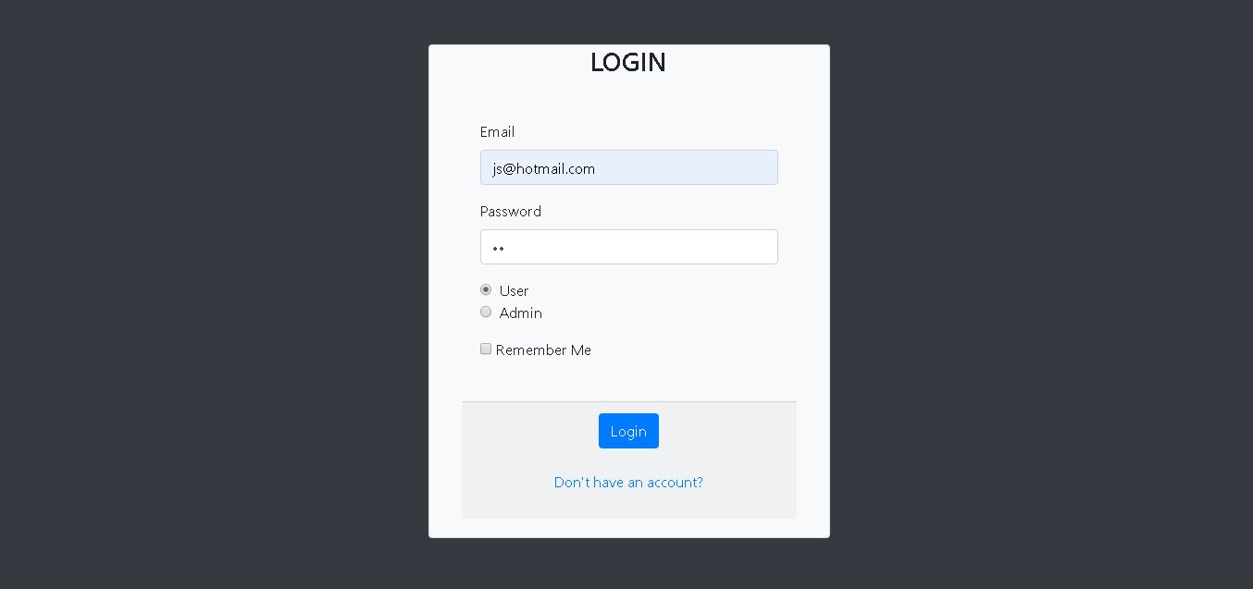

Figure 32: logging as user

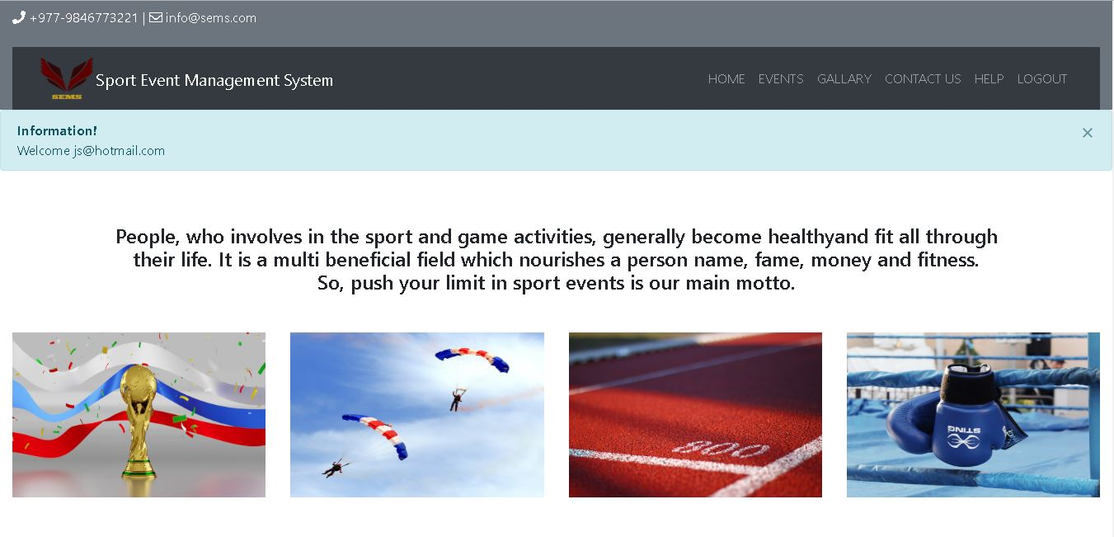

Figure 33: Home page after successful login as user

**Registration**

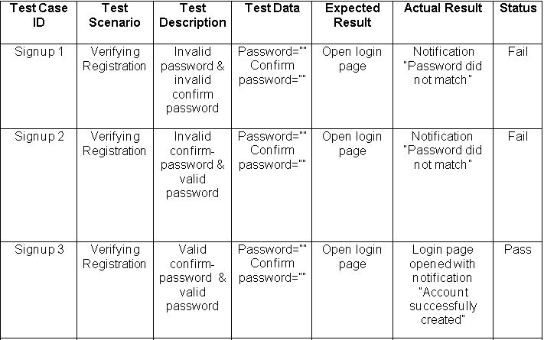

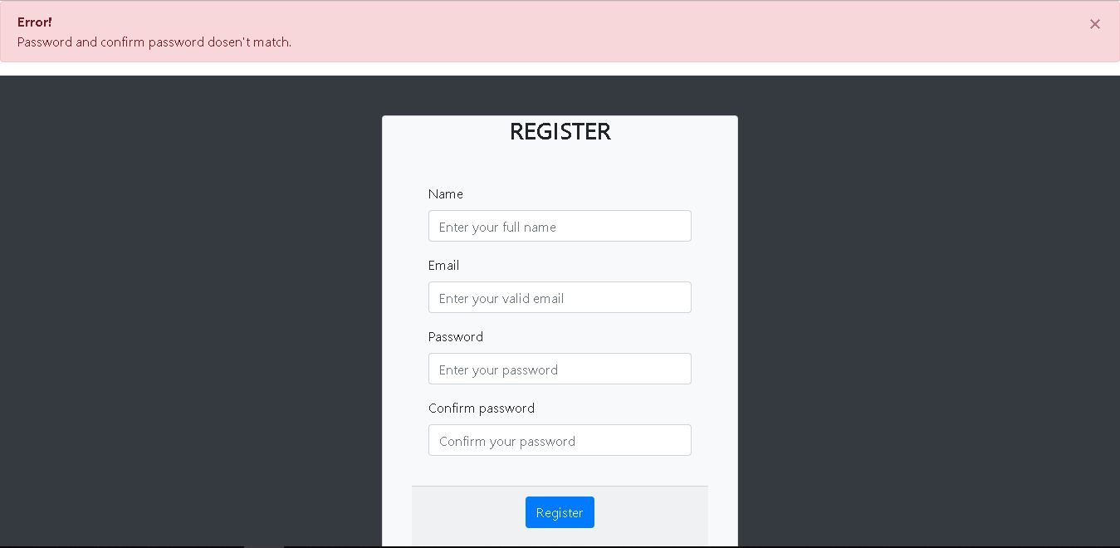

Figure 34: Notifying password and confirm password does not match

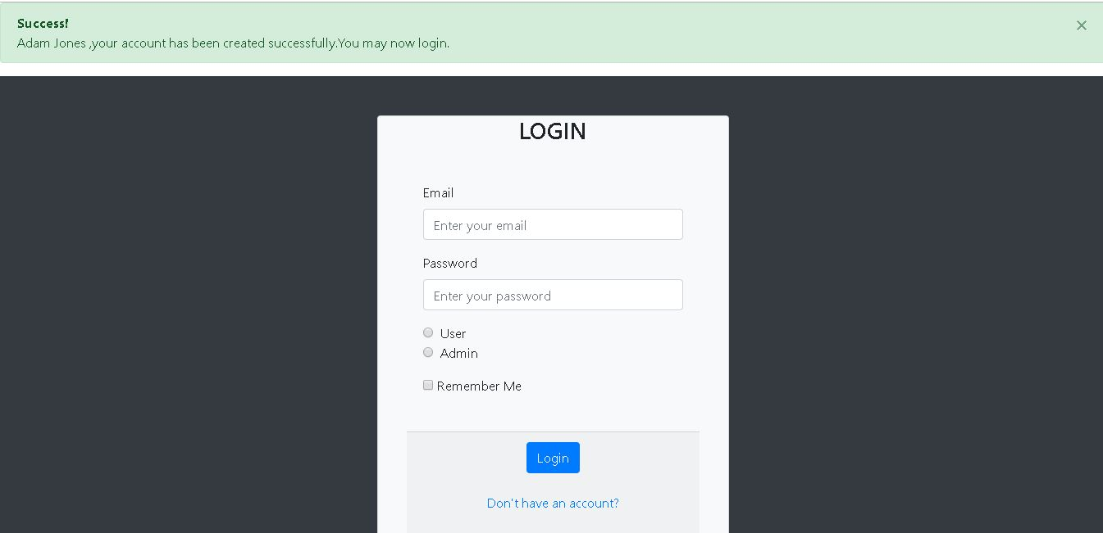

Figure 35: Login page after successful registration

**Adding Event**

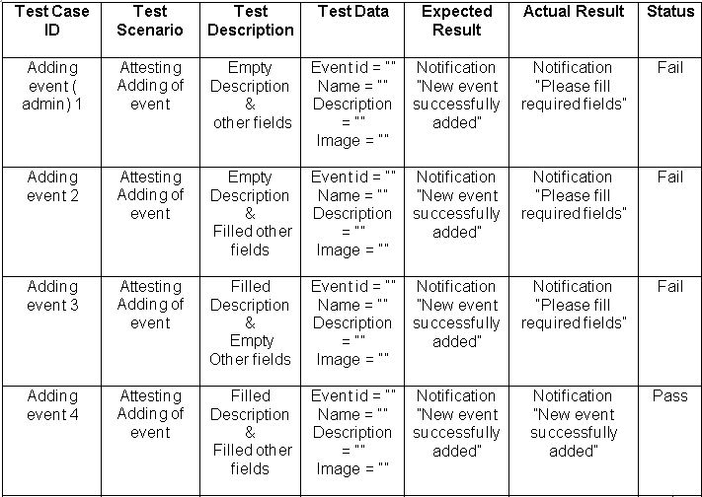

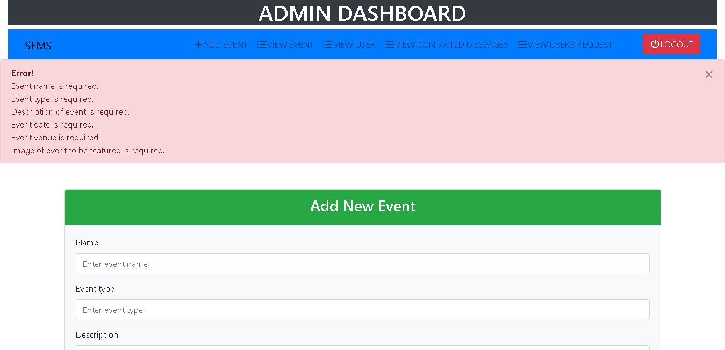

Figure 36: Error notification notifying to fill the required fields

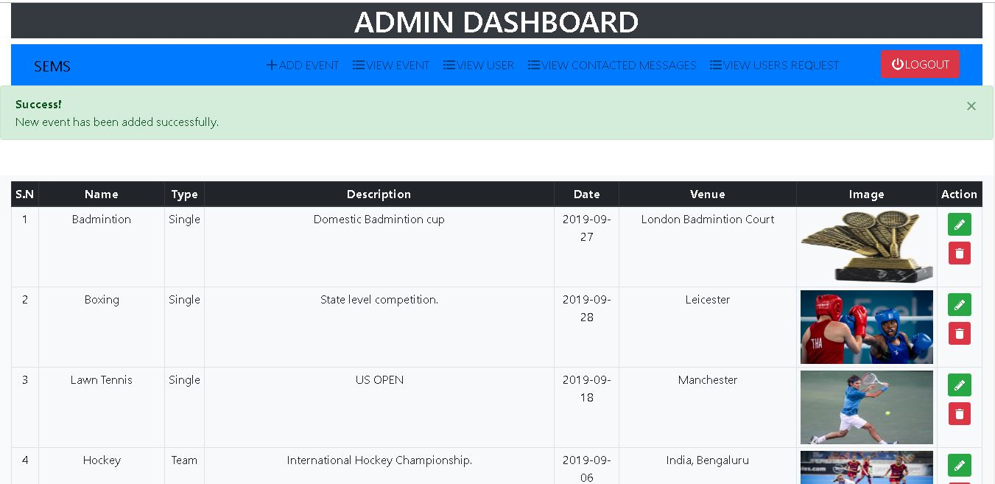

Figure 37: New event has been added successfully

**Updating Event**

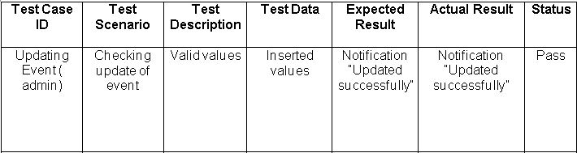

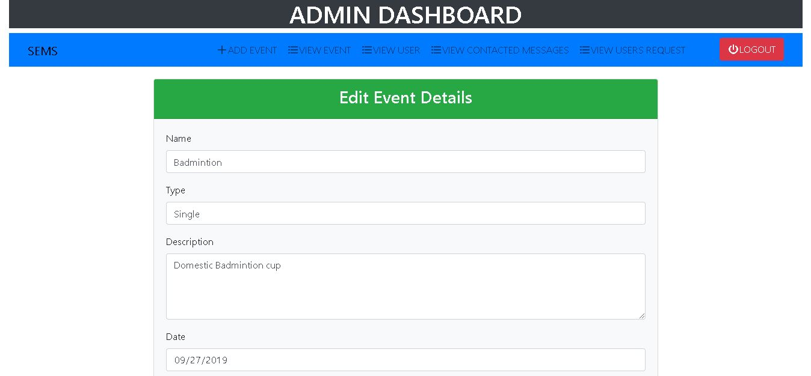

Figure 38: Updating event details

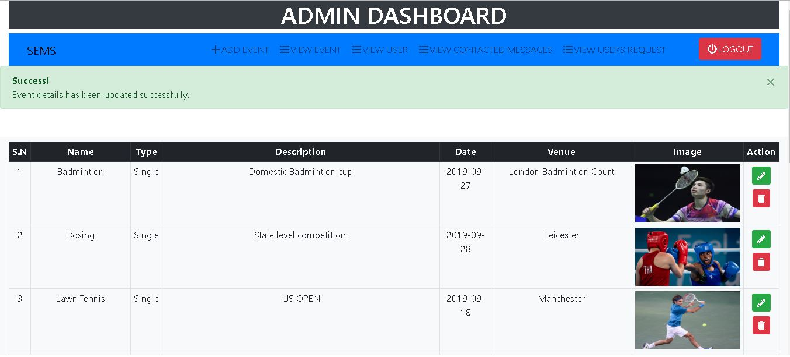

Figure 39: Badminton event's image has been updated successfully

**Deleting event**

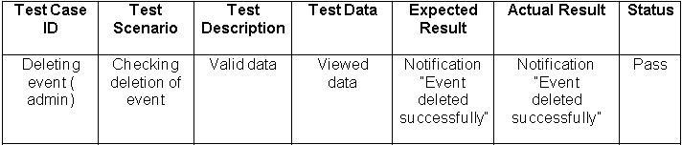

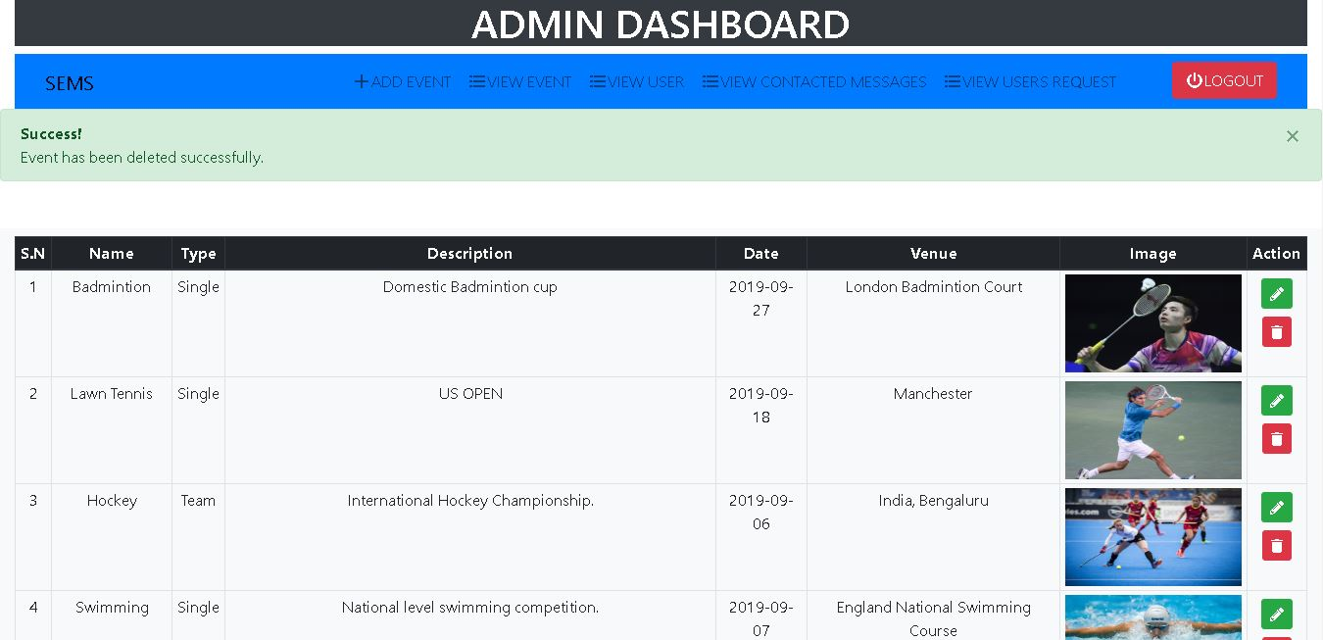

Figure 40: Boxing event has been deleted successfully

**Searching event**

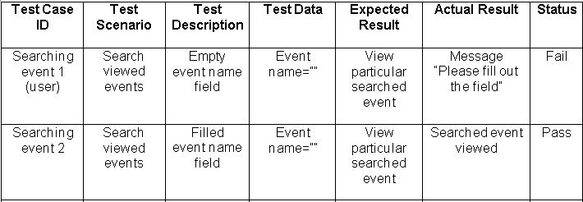

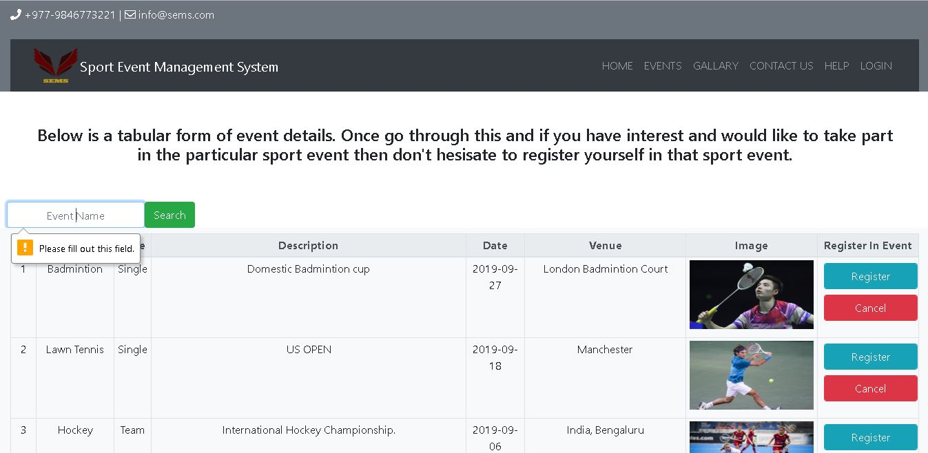

Figure 41: Notifying to fill the required event name

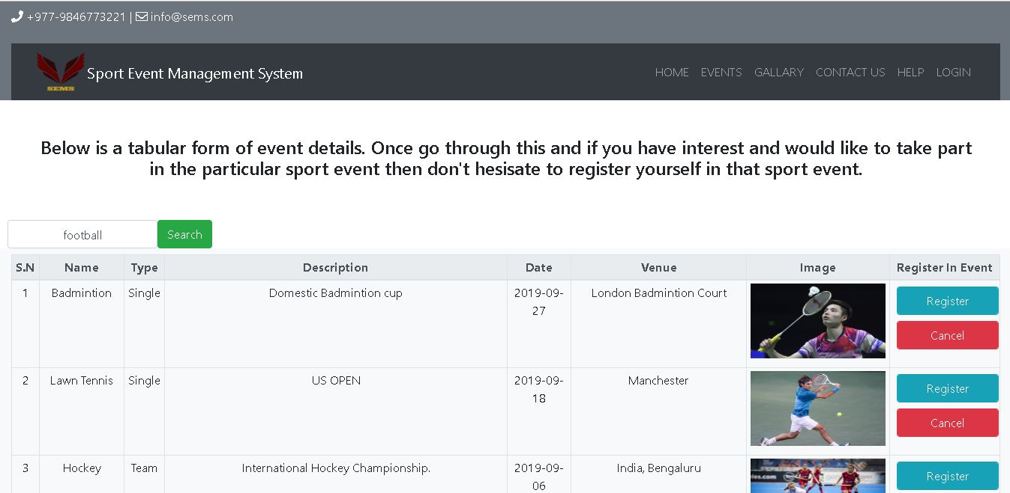

Figure 42: searching a particular event with event name

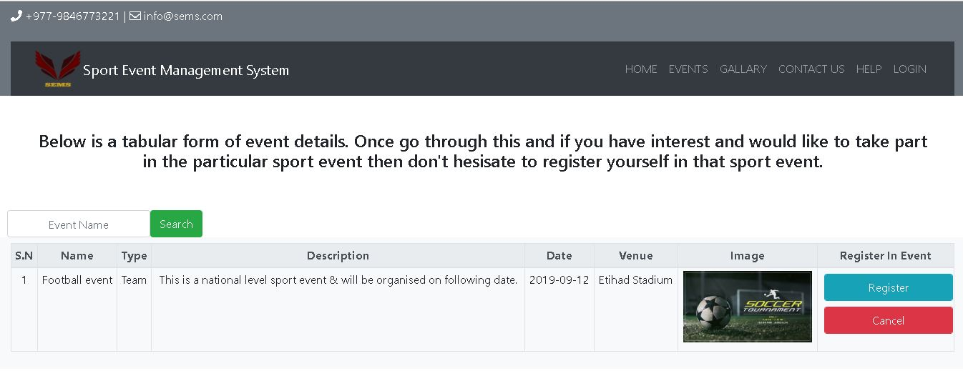

Figure 43: Result after searching with event name

**Registration in event**

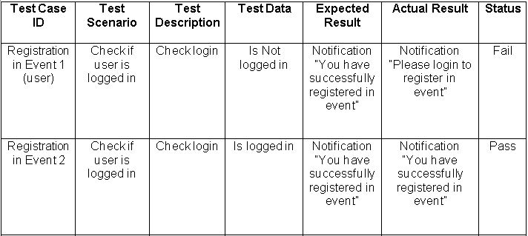

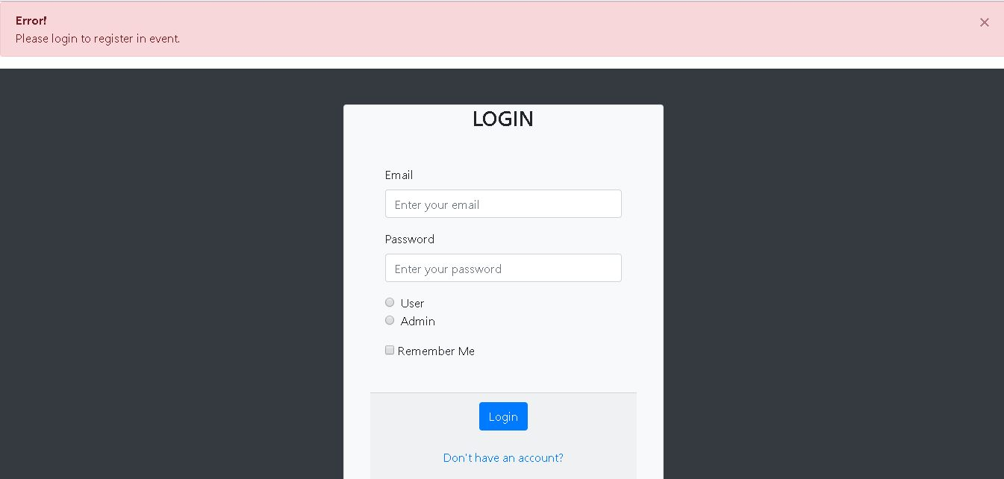

Figure 44: Notifying to login first for registration in event

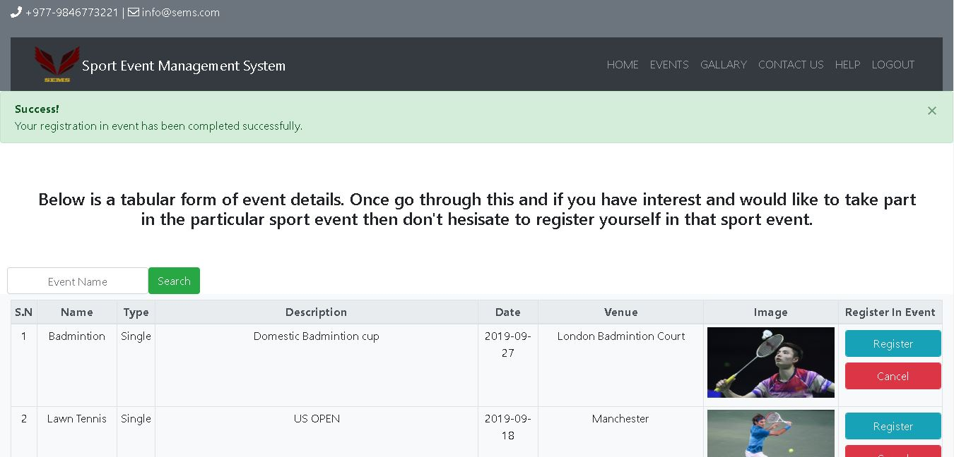

Figure 45: successfully registered in event after logging in

**Cancel registration in event**

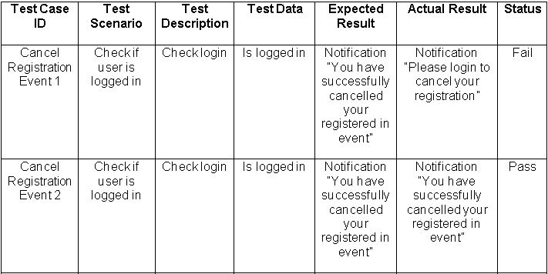

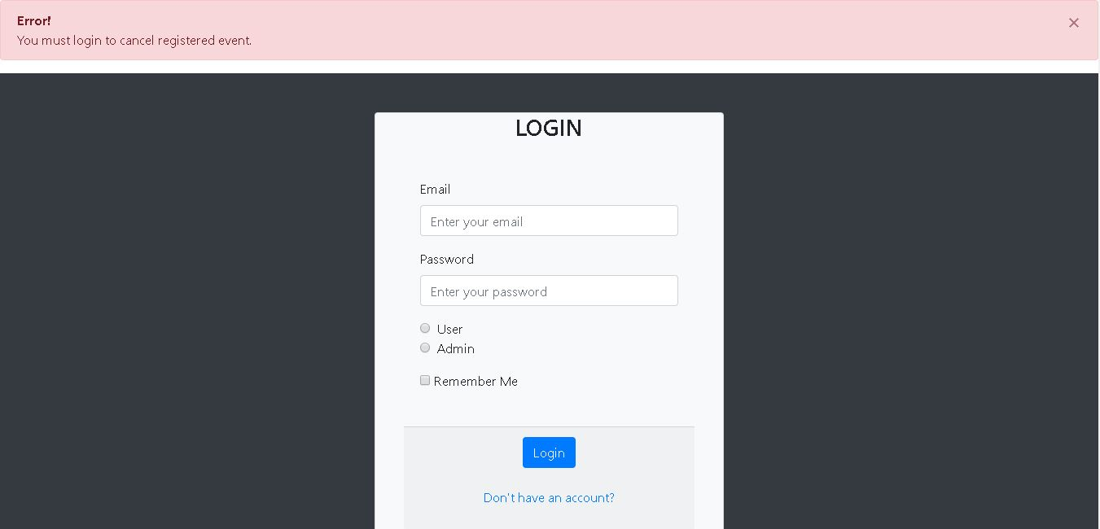

Figure 46: Notifying to login first for cancelling the registration in event

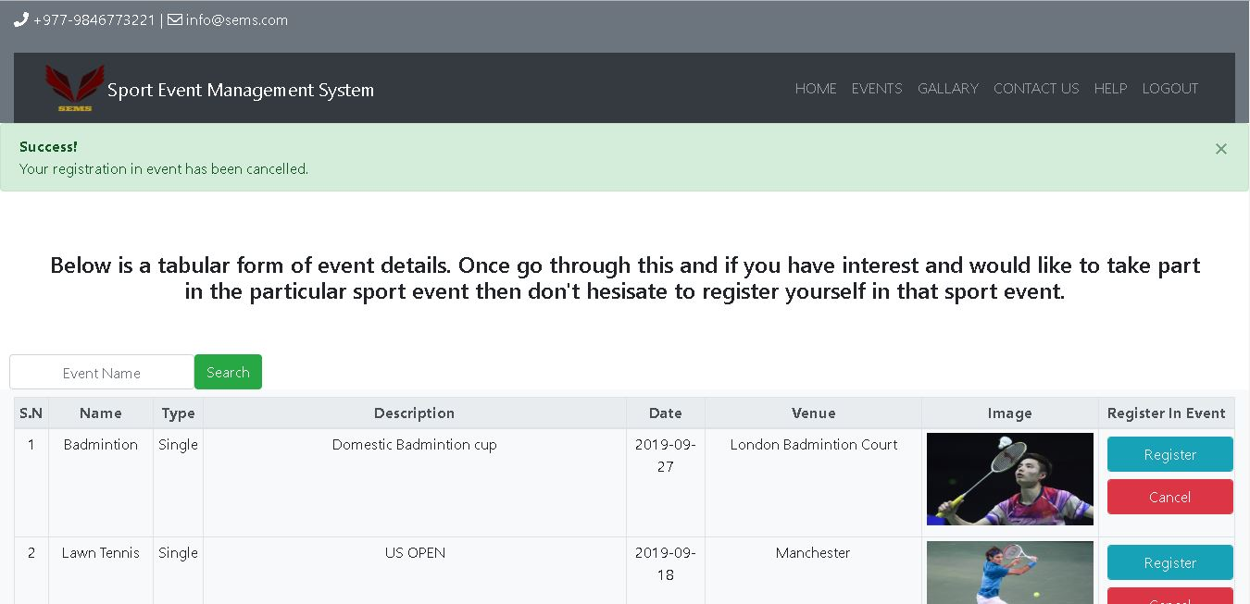

Figure 47: Registration in event cancelled successfully

**Logging out**

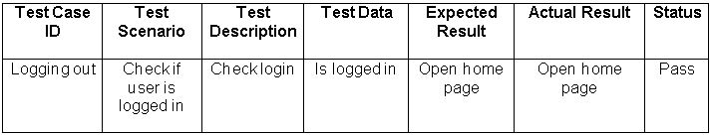

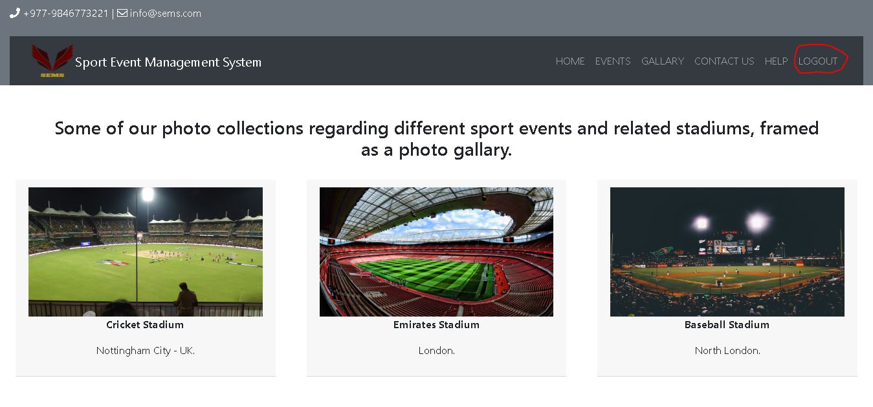

Figure 48: Page before logging out

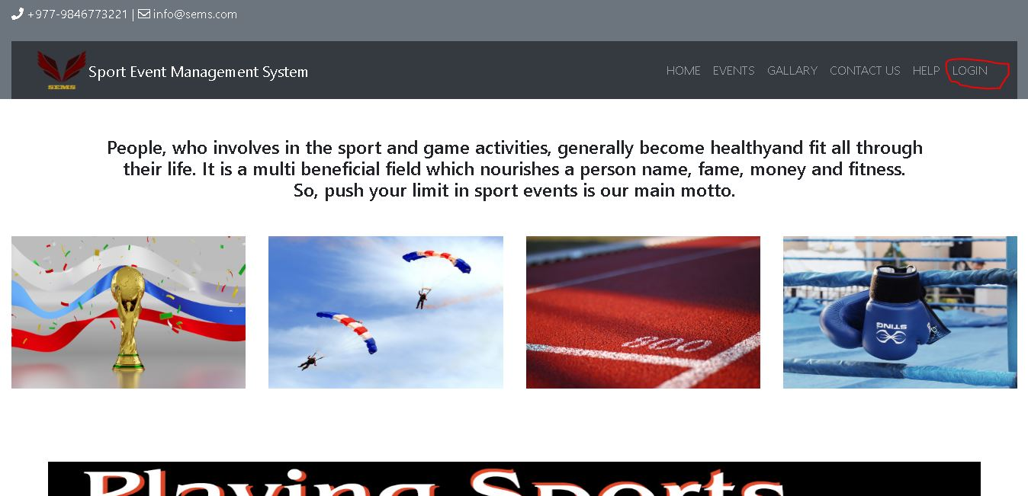

Figure 49: Home page after logging out

## 5.2 Unit-testing

Followings are the screenshots of the unit testing performed on Sport Events Management System

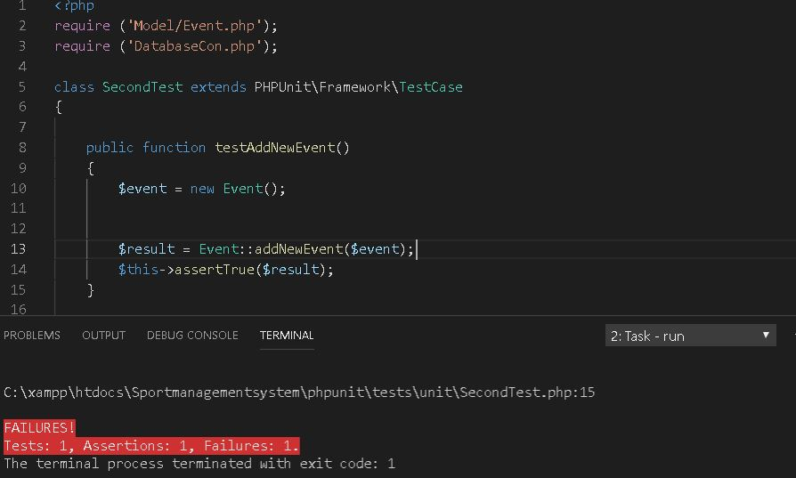

Figure 50: invalid testing of adding event

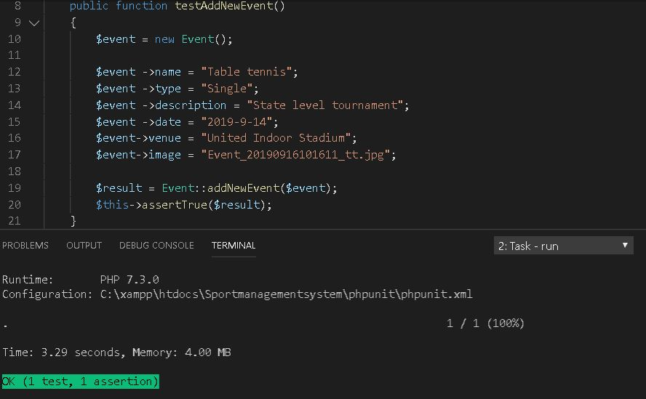

Figure 51: successful testing of adding event

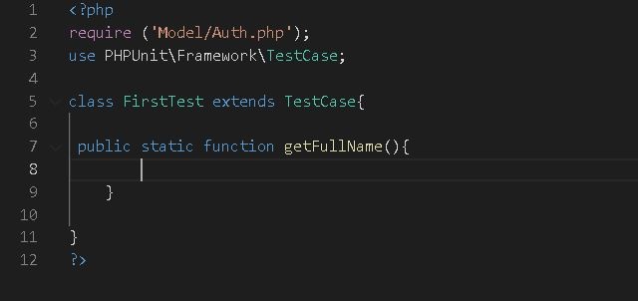

Figure 52: testing of empty method

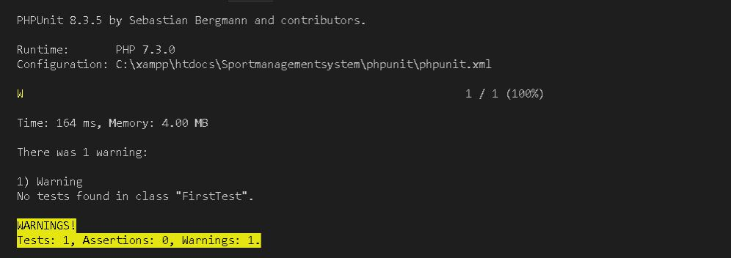

Figure 53: Warning 0 assertions

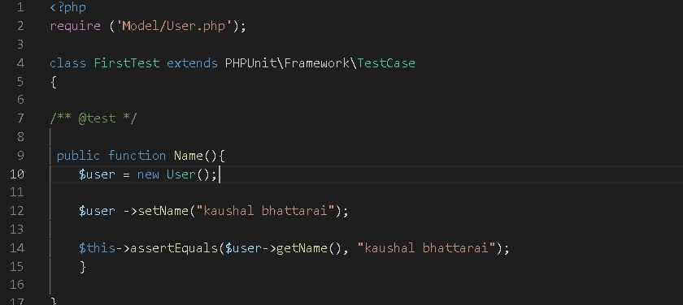

Figure 54: testing of setting and getting name

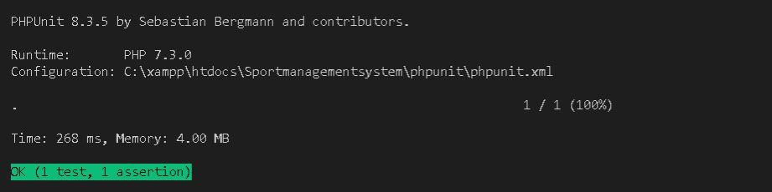

Figure 55: test successful

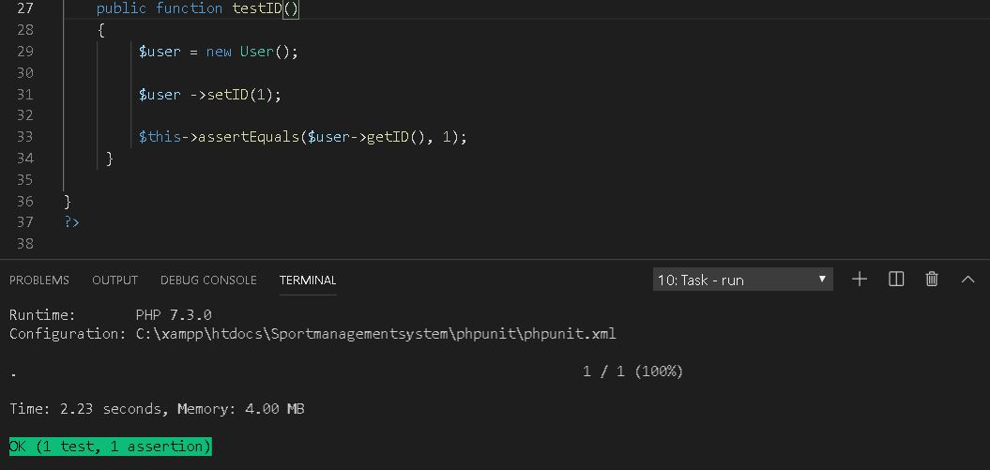

Figure 56: testing of setting and getting user id

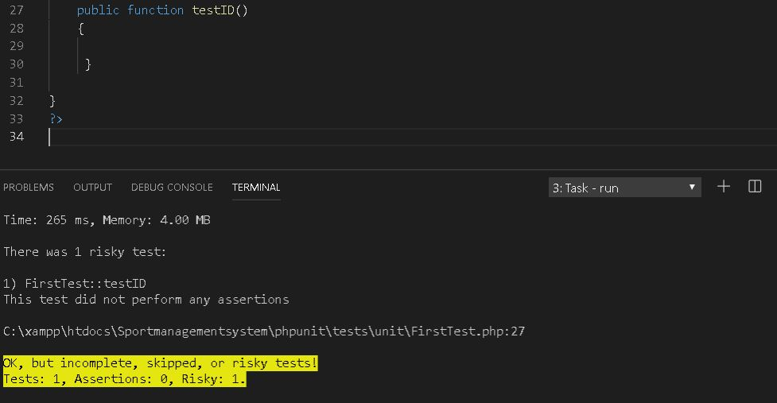

Figure 57: testing id fail

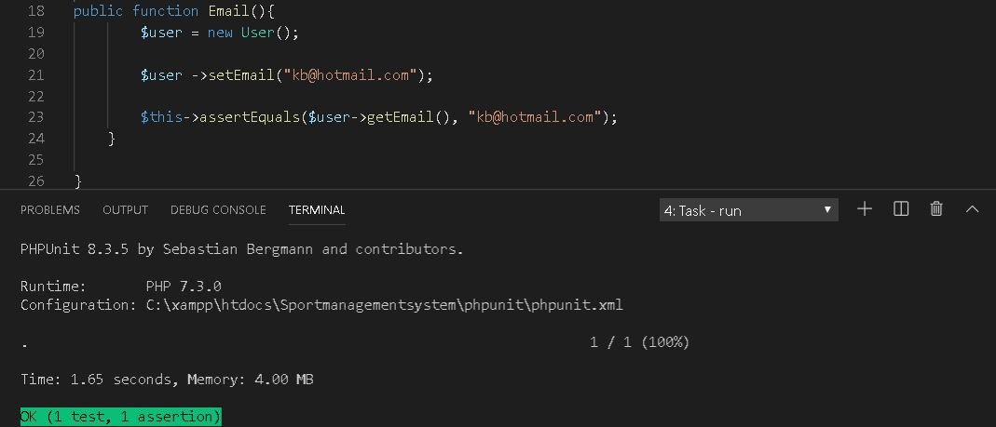

Figure 58: testing of setting and getting email

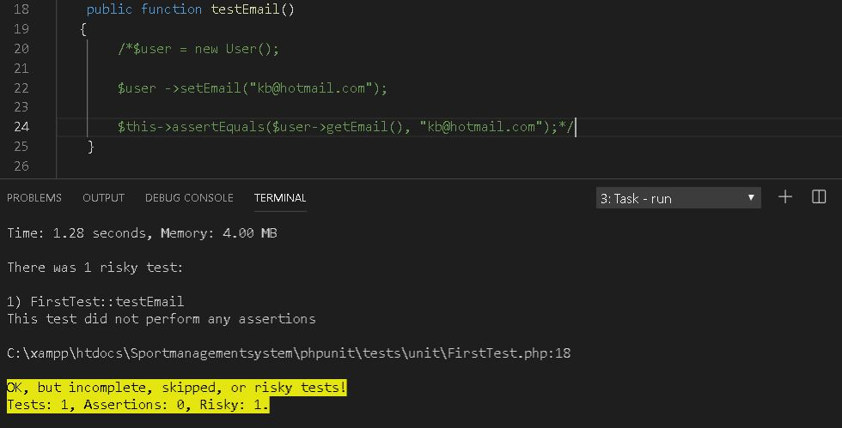

Figure 59: testing of email fail

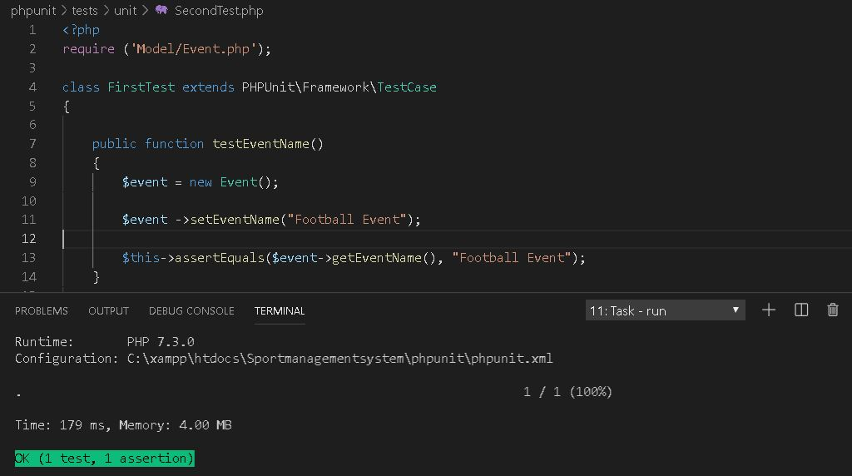

Figure 60: testing of setting and getting event name

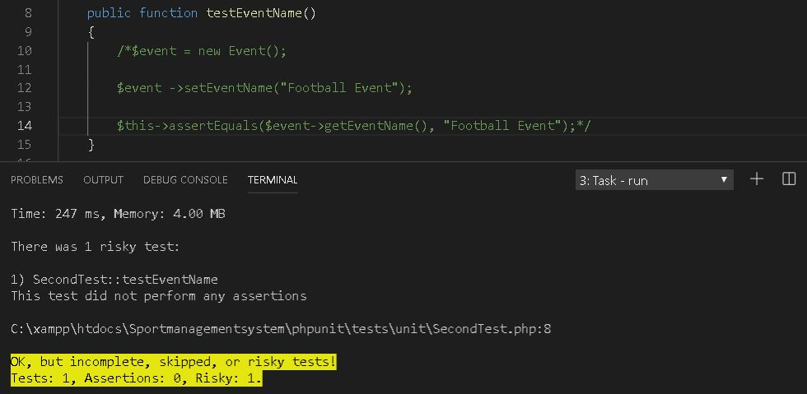

Figure 61: testing of event name fail

# Chapter-6 other project issues

## 6.1 Limitations

Everything has its good and bad sides and this project i.e. Sport Event Management System also have some limitations along with some benefits. So, following are the limitations of this project.

* This project (i.e. Sport Event Management System) has to be completed in a limited time. So, it does not achieve all quality attributes.
* This project does not facilitates user to use live features such as live streaming, live sport events etc.

## 6.2 Future Work

Future work includes all the features and functions that are to be implemented in the system for further improvement in future. Some of the features like instant notifications, live match, score updates etc. are not necessary in present system to function the core part. So, they are considered as a future work or plan. In future, these features could be implemented in the system to improve the accessibility and efficiency of the system.

## 6.3 Risk Management

Following table illustrates all the possible risks that were identified at the beginning of this project and the actual risks that were found during the development of the project and the way those risks were minimized or solved.

|  |  |  |
| --- | --- | --- |
| Possible Risks | Actual Risks | How they were minimized |
| Criteria not achieved | Failure of the system | This risk was minimized by the use of back-ups that were made during the development of project. |
| Failure of the system |
| Lack of proper budget and time allocation | Malwares | By using different anti-malwares, they were detected and then removed from the system. |
| Less User friendly |
| Malwares | Lack of proper time allocation | By increasing the amount of work per hour or day as per priority of the tasks, this risk was minimized. |

Table 5: Risk comparison table

## 6.4 Configuration Management

Configuration management can be regarded as asset control and is essential whether or not multiple versions of a deliverable will be created. At its simplest, configuration management is version control.

GitHub is a web-based version control and collaboration platform for the software developers. So, GitHub with ID **imkaushal10** is used to store this project (i.e. Sports Event Management System) files.

**GitHub Link:** <https://github.com/imkaushal10/CP>

Following is the file directory of my project published in GitHub.

Following is the screenshot of tree directory of my project files on local computer.

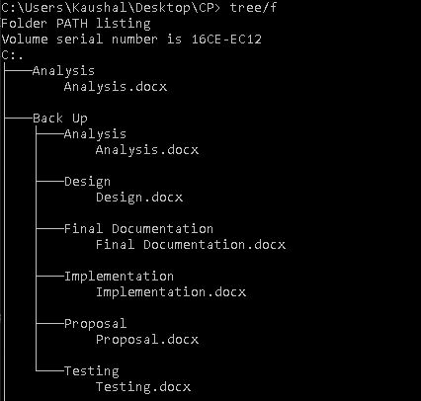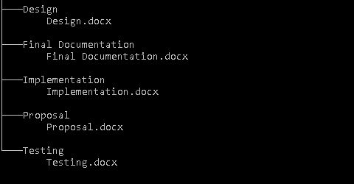

Figure : File directory in the local disk of computer

## 6.5 Other project issues

Different type of issues had arisen during the development of the project. Such as political issues, social issues, etc. Some issues that were raised are as follows;

* Time issue: A task estimated at 17 days actually took more than that.
* Technical issue: Some of the core problem in the system were difficult to solve by the lack of required resources. Later on, this problem was solved.
* Social issue: This system (i.e. Sport event Management System) facilitates all (in the social context) equally. In the process of that the system compromised on various factors regarding user friendliness, accessibility etc.

## 6.6 User Manual

Following is the user manual that can assists to use this system i.e. Sport Event Management System in an easy way.

**For registering in event**

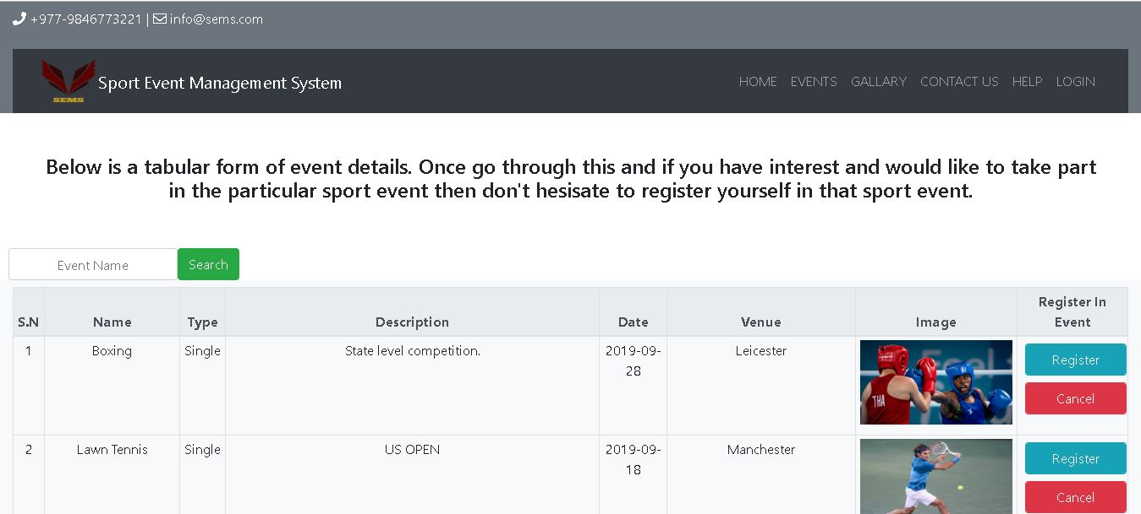

Figure 63: Events page where one can register themselves in a sport event

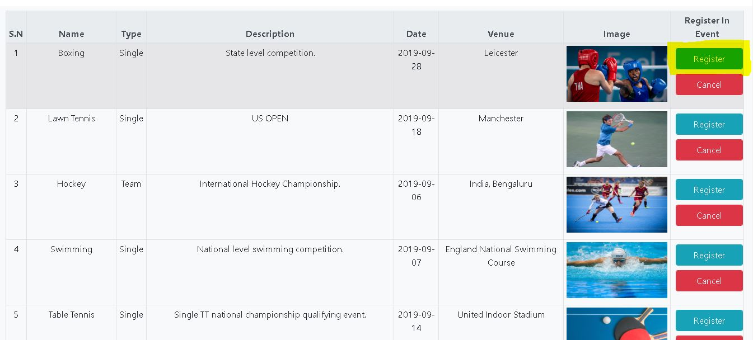

Figure 64: Click on register to register yourself

**For logging in or to register a new account**

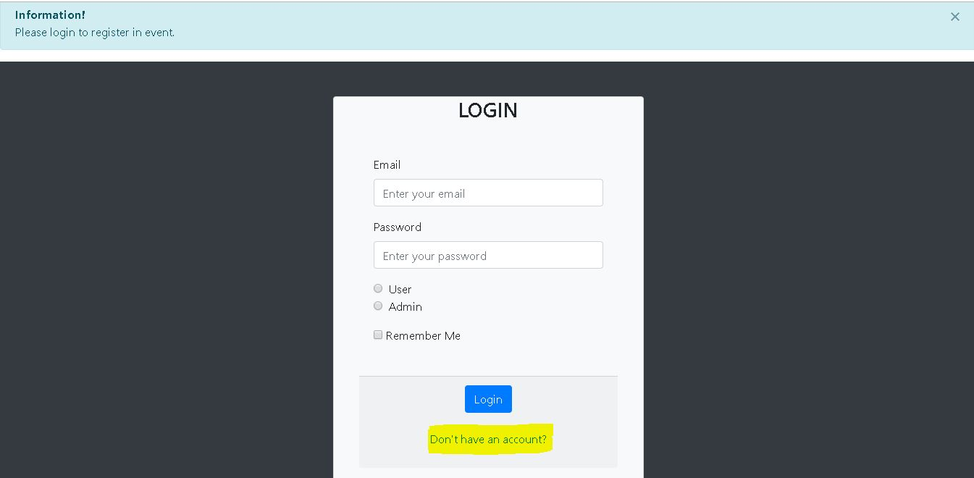

Figure 65: Page where one can login or register their account

**For contacting admin**

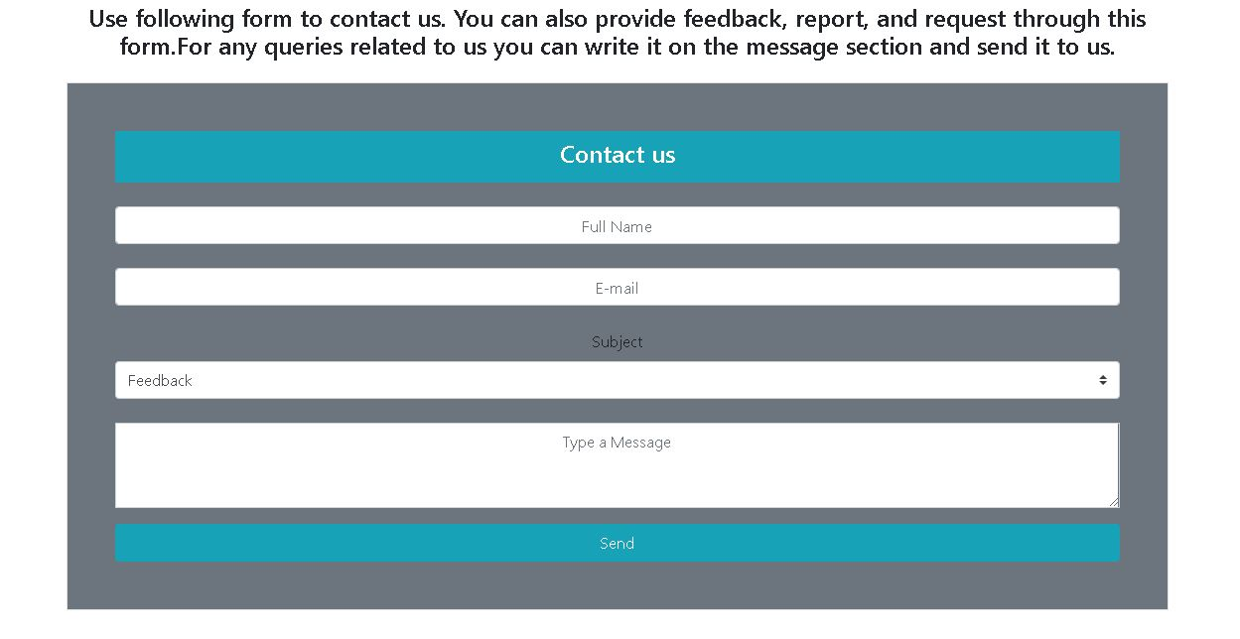

Figure 66: contact us page where one can give feedbacks, report or request

# Chapter-7 Conclusion

As proposed, this project (Sport Event Management System) has been developed using waterfall model methodology and MVC (Model view and Controller) design pattern. All the steps under the waterfall model i.e. Analysis, Design, Implementation, Testing, has been followed. Different works/tasks were categorized on the basis of WBS (Work Break- down Structure) and different milestones were set. As per that milestones tasks were performed and completed on time.

In this way, by breaking down works, setting milestones for that works and by finishing them as per the milestones, the project has been completed.

The completed system is able to manage all the details of sport events and the participants in a sport events. Therefore, by incorporating all the essential features and functions the project has been developed in a systematic way.

# Appendix

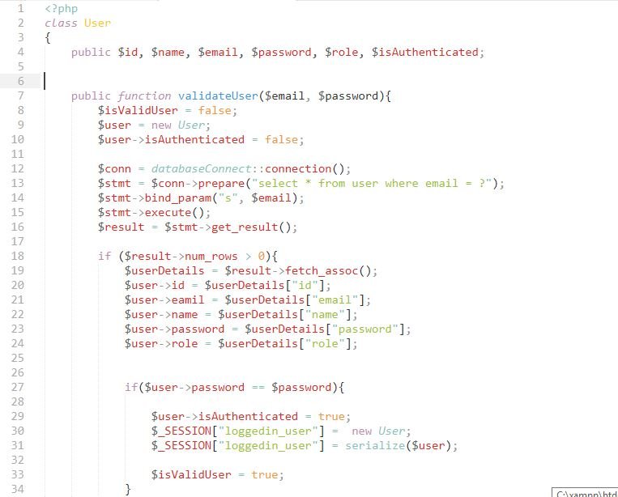

Figure 67: User class

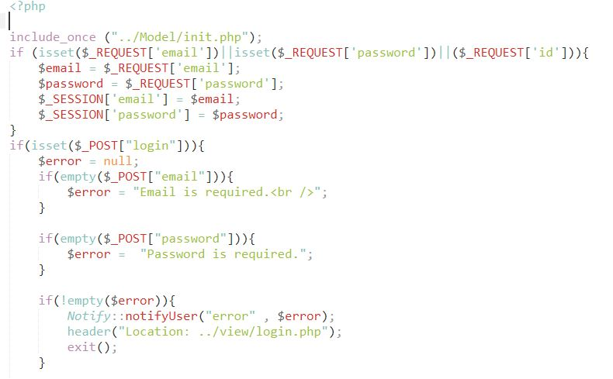

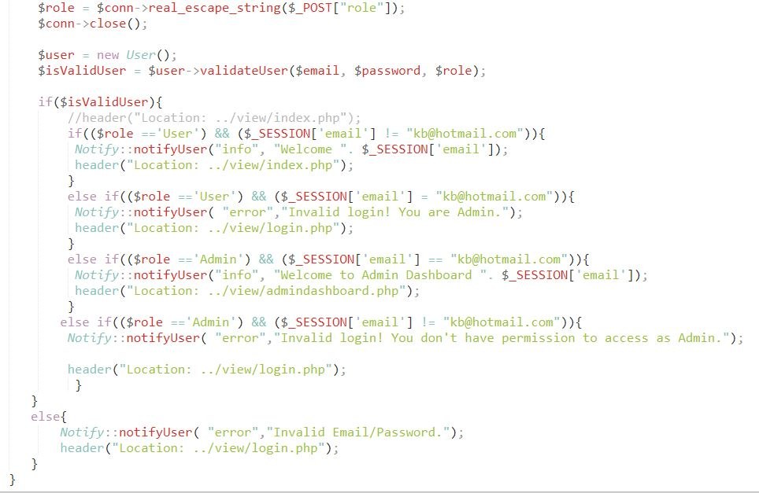

Figure 68: login controller

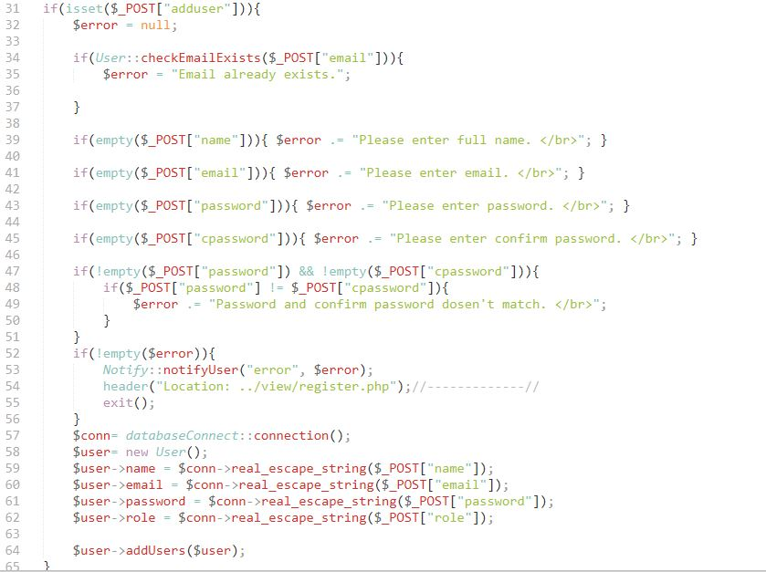

Figure 69: registration controller

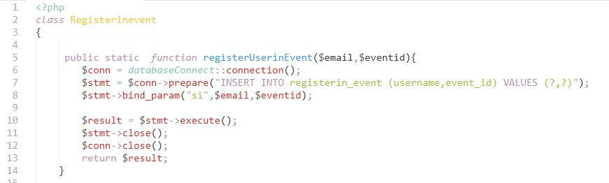

Figure 70: register in event class

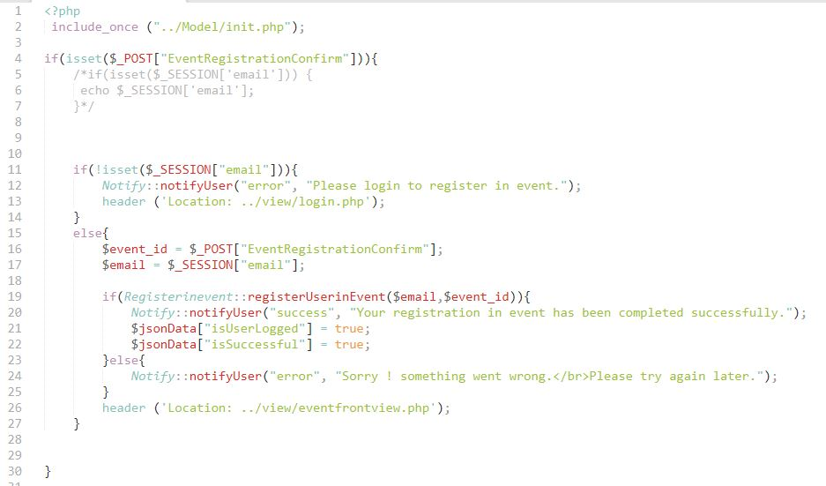

Figure 71: register in event controller

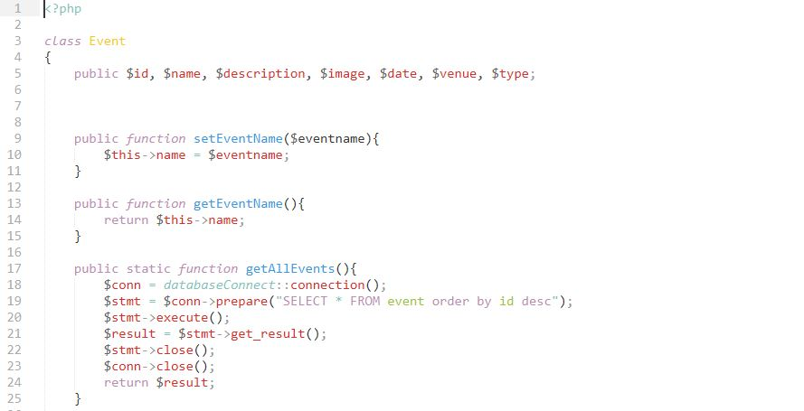

Figure 72: event class

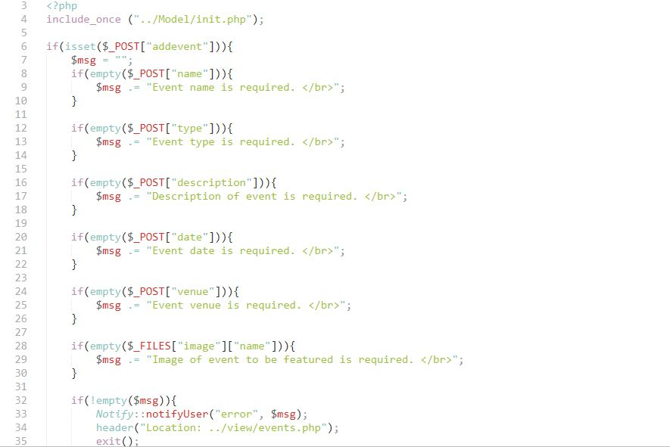

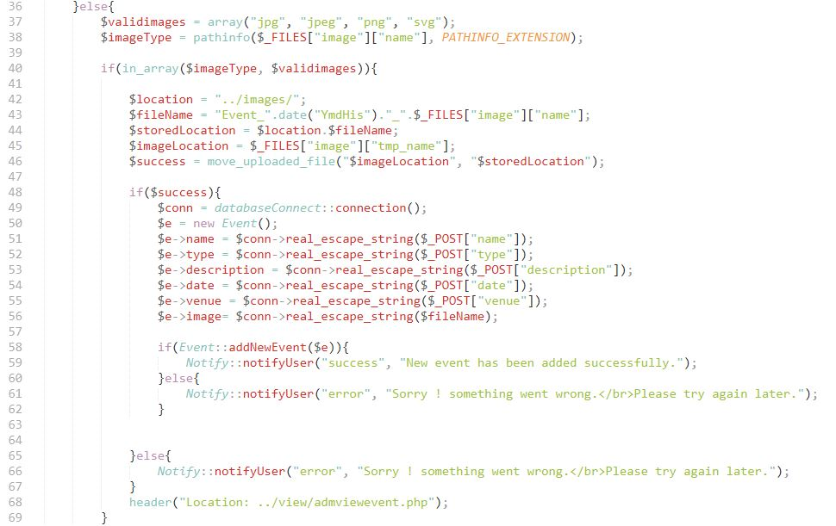

Figure 73: event controller

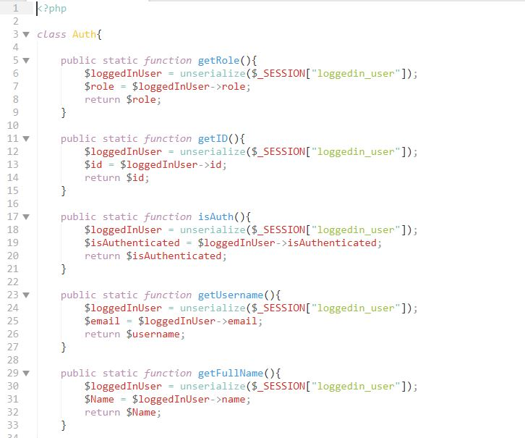

Figure 74: authentication

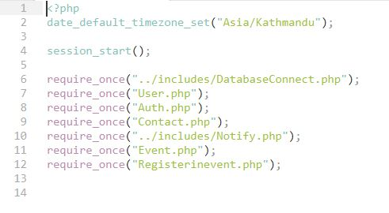

Figure 75: calling of classes

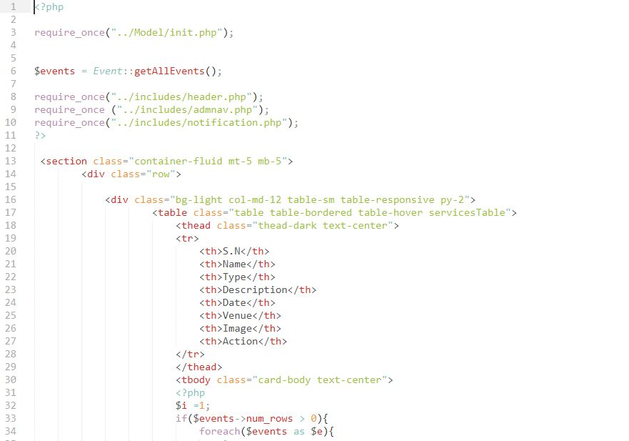

Figure 76: to view events